Project report on

“COVID-19 Real-Time Android App”

**Submitted by**

**Aditya Mishra**

**Meet Mewada**

**Om Dubey**

**Sarvesh Karangutkar**

**Project Guide**

**Ms. Smita Dandge**



**Department of Computer Engineering**

***ZAGDU SINGH CHARITABLE TRUST (REGD.)***

**THAKUR POLYTECHNIC**

**(**An ISO 9001:2015 Certified Institute**)**

Thakur Complex, West to W.E. Highway, Kandivli (E), Mumbai – 400 101.

**2020-2021**



**PROJECT APPROVAL SHEET**

Academic Year 2020-2021

This Project work entitled

“COVID-19 Real-Time Android App”

By

**Aditya Mishra**

**Meet Mewada**

**Om Dubey**

**Sarvesh Karangutkar**

Is approved for the award of the

**DIPLOMA**

**IN**

**COMPUTER ENGINEERING**

Ms. Smita Dandge

**PROJECT GUIDE/MENTOR**

--------------------------------- ---------------------------------

**EXTERNAL EXAMINER**  **INTERNAL EXAMINER**



**Affiliated to Maharashtra State Board of Technical Education (MSBTE) Mumbai**

**C E R T I F I C A T E**

This is to certify that

**Mr.** **Aditya Mishra – Enrollment No : 1705220547**

**Mr. Meet Mewada – Enrollment No : 1805220493**

**Mr. Om Dubey – Enrollment No : 1805220492**

**Mr. Sarvesh Karangutkar – Enrollment No : 1805220508**

from **0522, Thakur Polytechnic** Institute have completed project of final year having title **COVID-19 Real-Time Android App** during the academic year 2020-2021. The project completed by individually/ in a group consisting of **Four** persons under the guidance of the Faculty Guide.

**………………………………...**

**Name and Signature of Guide**

**Ms. Smita Dandge**

**Telephone :……………………………..**

----------------------- ------------------------

**H.O.D. (CO) PRINCIPAL**

(Ms. VAISHALI RANE ) (Dr. S.M.GANECHARI)

**2020-2021**

Project report on

“COVID-19 Real-Time Android App”

**Submitted by**

**Aditya Mishra**

**Meet Mewada**

**Om Dubey**

**Sarvesh Karangutkar**

**Project Guide**

**Ms. Smita Dandge**

****

**Department of Computer Engineering**

Zagdu Singh Charitable Trust’s

**Thakur Polytechnic**

**(An ISO 9001 : 2015 Certified Institute)**

**Thakur Complex, Kandivali (East), Mumbai 400 101**

**2020-2021**

**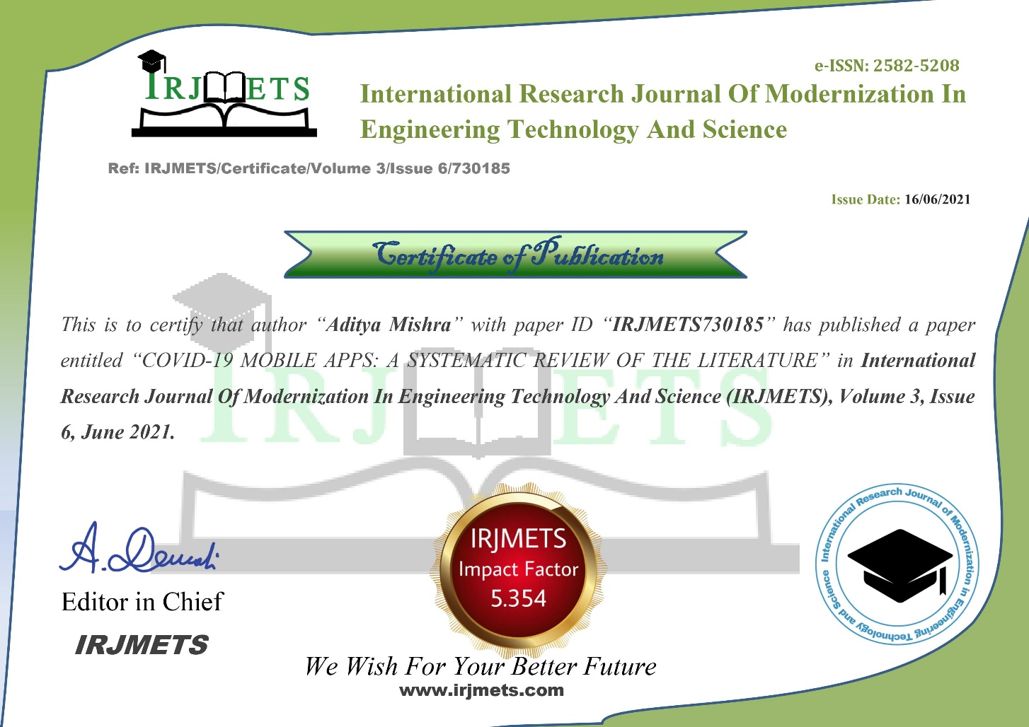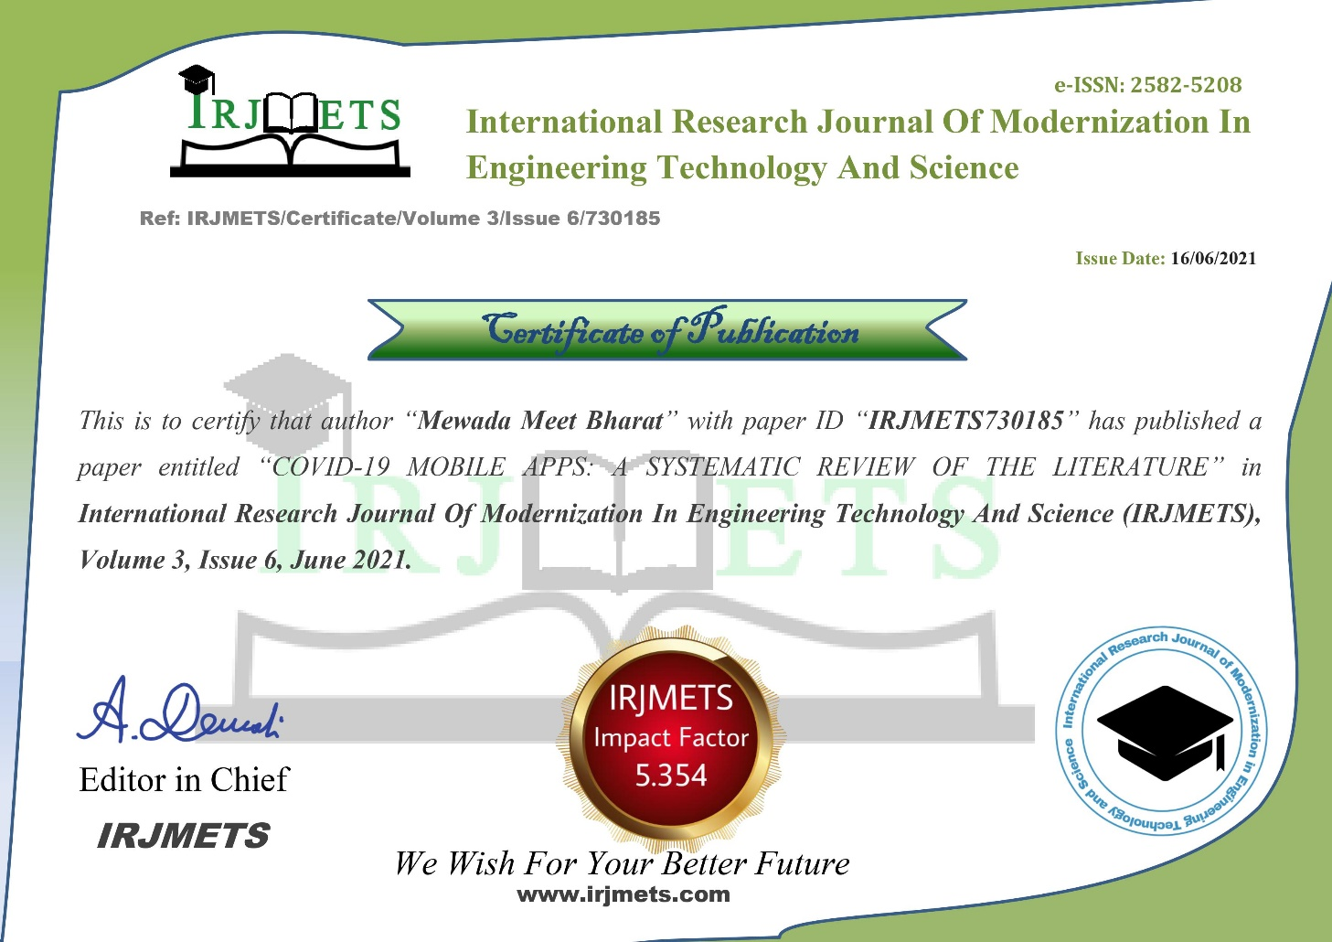**

**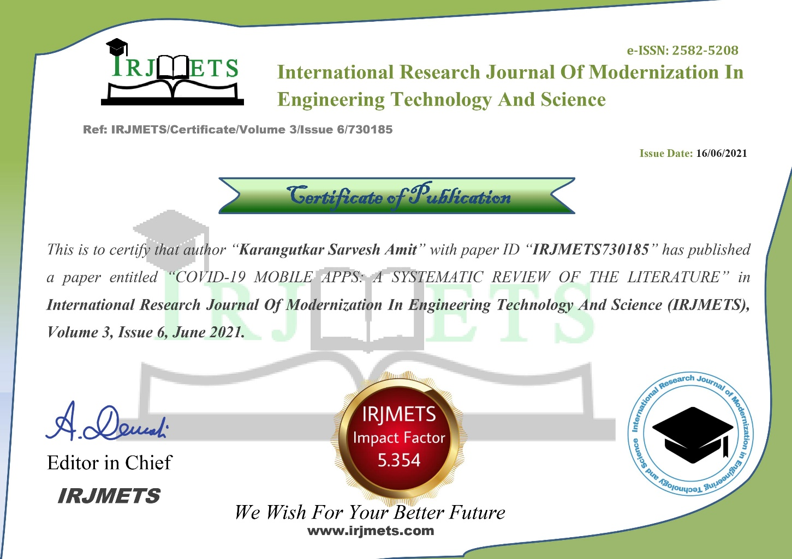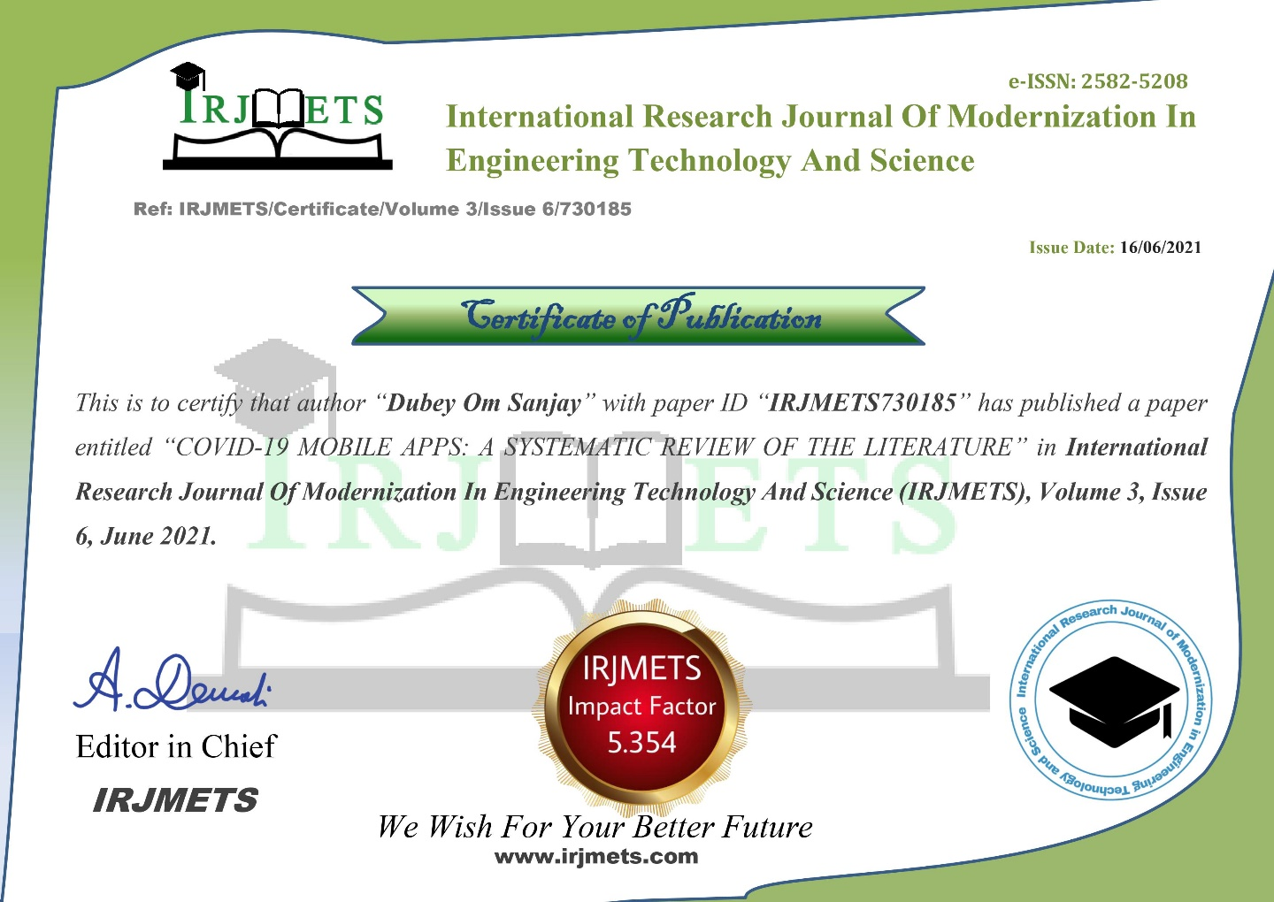**

**ACKNOWLEDGEMENT**

As a part of third year syllabus, we could successfully complete our project **“COVID-19 Real-Time Android App”**. We feel immense pleasure in submitting the report, while submitting this report we avail this opportunity to express our gratitude toward all those who have guided and helped us in completing this task successfully. Heading the list is our honorable Principal **Dr. S.M. Ganechari** who is beginner of our inspiration. We would like to thank our H.O. D of computer engineering **Mrs. Vaishali Rane** for ardour in inciting the subject and her valuable suggestion. We owe deep gratitude to our guide **Mr. Smita Dandge** who proved to be supportive guide to us. Apart from bringing to us what can be joy for creative, every time he acted promptly to correct our mistakes. The successful completion of this project is possible by his guidance and co-operation only, without which the work would have never been completed. We give our whole hearted thank to our college **Thakur Polytechnic** for giving us the opportunity & support to the project. Finally, we wish to express our deep sense of respect and gratitude to our parents who always bear with us in any critical condition and to all others, for sparing their time and helping us for completion of this project in whatever way they could.

Sincere thanks to all group members.

**Name of Members**

Aditya Mishra – 04

Meet Mewada – 83

Om Dubey – 82

Sarvesh Karangutkar - 98

**ABSTRACT**

The COVID-19 pandemic has spread with increased fatalities around the world and has become an international public health crisis. Public health authorities in many countries have introduced contact tracing apps to track and trace infected persons as part of measures to contain the spread of the Severe Acute Respiratory Syndrome-Coronavirus 2. However, there are major concerns about its efficacy and privacy which affects mass acceptance amongst a population. This systematic literature review encompasses the current challenges facing this technology and recommendations to address such challenges in the fight against the COVID-19 pandemic in neo-liberal societies.

**Background:** Contact tracing could also be a widely adopted television used to identify, assess and handle folks that are exposed to novel infectious diseases. mobile apps employing a digital technology system, called "proximity tracking", are used as a television to manage the COVID-19 pandemic.

**Objective:** The target of this review is to seem at the use of Mobile apps for contact tracing to manage the worldwide COVID-19 pandemic.

**Method:** Searches of various electronic databases, like PubMed, PubMed Central, Google Scholar, and Google were performed using the search items 'mobile app,' 'tracing' and 'COVID-19'. The search was done between 18 and 31 May 2020.

**Findings:** The invention revealed that a complete of 15 countries within the world developed and actively used 17 mobile apps for contact tracing to regulate the COVID-19 pandemic during the chosen time-frame. China and Malaysia were using only two apps. Three of the 17 apps were protected by the country's data protection laws. The results indicated that the mobile app was used to monitor self-isolating individuals, to identify persons not wearing masks, whether or not that they had close contact with an infected person, the precise time and place of encounter and confers a possible risk of infection.

**Conclusions:** Contact tracking has been revealed to be an important public health approach to fight the pandemic and other new infectious diseases. However, caution is required to generalize the usability of apps, especially in LMICs, and to deal with concerns about data anonymity, data privacy and usage, and data rights.

**INDEX**

|  |  |  |
| --- | --- | --- |
| **CHAPTER** | **TITLE** | **PAGE NO** |
| **1.** | **Introduction** | **11** |
| **2.** | **Literature Survey** | **15** |
| 2.1 | Abstract | 16 |
| 2.2 | Background | 16 |
| 2.3 | Objective | 16 |
| 2.4 | Method | 16 |
| 2.5 | Results | 16 |
| 2.6 | Conclusion | 16 |
| 2.7 | Methodology | 16 |
| 2.8 | Statistical Analysis | 17 |
| **3.** | **Scope of the Project** | **18** |
| 3.1 | Background | 19 |
| 3.2 | Study Selection | 20 |
| 3.3 | Mandatory Application of Contact Tracing Apps in East Asia | 20 |
| **4.** | **Methodology** | **22** |
| 4.1 | Research Methodology | 23 |
| 4.2 | Planning the Review | 24 |
| 4.3 | Conducting the Review | 25 |
| **5.** | **Details of Design, Working and Process** | **28** |
| 5.1 | Home Page | 29 |
| 5.2 | Sign Up Page | 29 |
| 5.3 | Session Page | 29 |
| 5.4 | Instruction Page | 30 |
| 5.4.1 | Kotlin | 30 |
| 5.4.2 | Koin | 32 |
| 5.4.3 | MVVM Architechture | 33 |
| 5.4.4 | Material Design | 34 |
| 5.4.5 | Android X | 35 |
| 5.4.6 | Retrofit 2 | 36 |
| 5.4.7 | Moshi JSON Parser | 37 |
| 5.4.8 | Android Architecture Component | 38 |
| 5.4.9 | Github | 39 |
| 5.4.10 | Windows 10 | 40 |
| 5.4.11 | VS Code | 42 |
| 5.4.12 | Android Studio | 44 |
| **5.5** | **Design** | **47** |
| 5.6 | From Design Idea to User Testing | 47 |
| **5.7** | **Process and Function of Covid-19 Tracker Application** | **50** |
| 5.7.1 | Home Screen | 50 |
| 5.7.2 | Update Section | 52 |
| 5.7.3 | Covid-19 Real-Time Data Page | 52 |
| 5.7.4 | Search Section | 55 |
| 5.7.5 | About Me Page | 56 |
| 5.8 | Database Inspector (Android Studio) | 56 |
| 5.9 | Frequently Asked Questions (FAQs) | 57 |
| 5.10 | Test Cases | 58 |
| 5.11 | Defect Report | 60 |
| **6.** | **Results and Applications** | **62** |
| 6.1 | Discussion of Results | 64 |
| **7.** | **Conclusion and Future Work** | **72** |
| **8.** | **References and Bibliography** | **73** |

**CHAPTER 1**

**INTRODUCTION**

**Chapter 1 : Introduction**

When news of an epidemic began to spread in a Chinese city in early 2020, no one anticipated the scope of the epidemic for the entire world in a very short period. From Wuhan (China) to New York (USA) through Africa, South America, Asia, and Europe, the new coronavirus, coronavirus disease 2019 (COVID-19) or severe acute respiratory syndrome coronavirus 2 (SARS-CoV-2), has paralyzed, to a greater or lesser extent, the life in many countries, causing thousands of deaths and about 6 million infections. For these reasons, the scientific community is on the alert by conducting studies on the virus, the disease it produces, the situation it creates, and the population it attacks, from different perspectives, including systematic reviews of the literature, such as the one presented in this paper.

However, researchers on this topic are not only biologists or physicians. It is worth noting the contribution of Maestre Maestre ([2020](https://www.ncbi.nlm.nih.gov/pmc/articles/PMC7591583/#B19)), President of the Society for Latin Studies, in an article on the virus that has caused the pandemic, in which, playing with different related terms, he explains that the neutral noun “virus” means “poison” in Latin, so most current research is trying to find a medicine that will kill the virus. Likewise, the Greek term ϕάρμακoν (in Latin pharmacum) also means poison. The relationship between the two terms is that pharmacies are looking for poisons that will kill the “poisons” that undermine people's health or their desire to be safe. Remember the symbol of the pharmacies, the “Bowl of Hygieia” with the snake that pours a “poison” into it that stops being a poison to become an antidote. The name “coronavirus” is given to it because, through the microscope, the “virus-poison” is shaped like a “crown” that makes it king of poisons.

However, in addition to scientists who study the pandemic, biologists, doctors, and humanists, educators are obliged to care for the psychological and emotional health, as well as cultivate the minds, of children. The consequences of the containment measures of COVID-19 are being detrimental to the mental health of people around the world. It is logical that the most vulnerable are children who do not understand what is happening and who, along with the concern and frustration of their elders, may present risk factors, such as anxiety and affective and post-traumatic stress disorders (Giallonardo et al., [2020](https://www.ncbi.nlm.nih.gov/pmc/articles/PMC7591583/#B11)). However, not only minors are affected. According to Roy et al. ([2020](https://www.ncbi.nlm.nih.gov/pmc/articles/PMC7591583/#B22)), more than 80% of people over 18 have shown the need for attention to their mental health as a result of the anxiety and stress experienced during the pandemic. Forte et al. ([2020](https://www.ncbi.nlm.nih.gov/pmc/articles/PMC7591583/#B9)) agree with this idea, stating that the pandemic has caused stress, psychological discomfort, sleep disorders, and instability, among others, in a large part of the population.

In this sense, many questionnaires have been applied to obtain information in the educational context or related to it from research groups at different universities, including the one from the IDIBAPS research group at the Hospital Universitario de Barcelona, concerning behaviors to reduce emotional distress during the pandemic and confinement by COVID-19, Universidad de las Palmas de Gran Canaria on family relationships during confinement: Study of the effect of COVID-19 in the family context, Universidad de Oviedo, as a longitudinal study on how isolation and the practice of physical activity (PA) during confinement is affecting to offer effective strategies that it called “pills”: EDAFIDES Questionnaire COVID-19,  Euskal Herriko Unibertsitatea, to find out about the situation of university students in confinement and to propose improvements.Universidad da Coruña y Universidad de Jaén, on the activities of children in Spanish homes in times of confinement. This last questionnaire was applied in Spain and in South America:

Based on the above-mentioned questionnaires, there is a concern to analyze how confinement has affected children under 12 at the motor and psychological levels. This literature review is carried out and explained in detail in the procedure and search strategy of the methodology. The impact of the pandemic is such that many national and international journals are offering special issues on COVID-19, including Frontiers, which, being digital, contains 229 articles signed by many authors from various countries, which look at the subject from different perspectives: there are eight that refer to age and especially to children in some way, including: who cares about the elderly (Fischer et al., [2020](https://www.ncbi.nlm.nih.gov/pmc/articles/PMC7591583/#B7)), physical inactivity (Ricci et al., [2020](https://www.ncbi.nlm.nih.gov/pmc/articles/PMC7591583/#B21)), age distribution (Cortis, [2020](https://www.ncbi.nlm.nih.gov/pmc/articles/PMC7591583/#B4)), and newborns (Ovali, [2020](https://www.ncbi.nlm.nih.gov/pmc/articles/PMC7591583/#B20)), but none discusses parents' views on the period of confinement from the psychological, educational, academic, physical, and emotional points of view of their children. Neither do they inquire into the opinion of the children themselves, understanding by these those who are in infant and primary education, that is, up to the age of 12.

Education must seek to provide the child with a comprehensive education, trying to help his or her physical, emotional, intellectual, family, social, and moral development. Active methods are crucial for early childhood education, and teachers are needed to apply them in schools (Salvador, [2008](https://www.ncbi.nlm.nih.gov/pmc/articles/PMC7591583/#B24)), now in the homes of their students, which they access through the Internet. The role of parents is also to educate, but from different perspectives, complementing those of teachers in the acquisition of children's learning. For these reasons, many families say that they do not know how to undertake these activities with their children for so long.

Likewise, the lack of other family members, such as grandparents, who had been playing a role in accompanying, especially with children in preschool, complicates the state of confinement and the lack of school attendance that is taking place, initially planned for 6 months in a row. The study by Clemente-González ([2016](https://www.ncbi.nlm.nih.gov/pmc/articles/PMC7591583/#B3)) of the University of Murcia highlights the relevance of grandparent–grandchild relationships and the role of the former in the social and emotional development of the child, which gives great significance to their grandparents for the appreciation observed in them, recognizing their importance in the family structure. At this point, it is also necessary to point out the lack of relationships between equals, which is so important for the correct emotional development of children.

Another important aspect that has been affected by the coronavirus pandemic is the practice of PA. Many schoolchildren practice physical exercise based solely on the subject of Physical Education. This subject is not only based on motor skills but is a practice that affects schoolchildren in a global way, influences many aspects of their daily lives, and helps teachers to better understand students in their different dimensions (Founaud and González-Audicana, [2020](https://www.ncbi.nlm.nih.gov/pmc/articles/PMC7591583/#B10)). Lack of PA is associated with obesity, as indicated by different studies that relate the regular practice of physical exercise with the reduction of health problems (Castañeda-Vázquez et al., [2020](https://www.ncbi.nlm.nih.gov/pmc/articles/PMC7591583/#B2)).

The opinion article written by the Spanish secondary school teacher, Fandino-Pérez ([2020](https://www.ncbi.nlm.nih.gov/pmc/articles/PMC7591583/#B6)), is significant in which he reflects on the virtuality of education and his position regarding personalized education, so demanded in times of normality, where teachers and students know each other, interact, and socialize, precisely the attitude that has taken away the virus. Fandino-Pérez says that the pandemic has put us in front of the mirror to see a distorted and absurd image of the work of teachers as producers of programming and good results, which turns them and their students into a kind of machine. We have forgotten the main thing: to be human beings capable of creating a better world and of overcoming ignorance, fear, and demagogy.

As a background to this study, we refer to March 11, 2020 when the World Health Organization (World Health Organization, [2020a](https://www.ncbi.nlm.nih.gov/pmc/articles/PMC7591583/#B31)) declared this disease produced by the coronavirus (COVID-19) to be a pandemic. It was first reported in Wuhan (China) on December 31, 2019. According to World Health Organization ([2009](https://www.ncbi.nlm.nih.gov/pmc/articles/PMC7591583/#B27)), the global public health community recognized the need for standardized research and data collection after the 2009 flu epidemics, so the WHO Expert Working Group on Special Research and Studies has developed several standard protocols for pandemic flu. This has led World Health Organization ([2019a](https://www.ncbi.nlm.nih.gov/pmc/articles/PMC7591583/#B29), [2020b](https://www.ncbi.nlm.nih.gov/pmc/articles/PMC7591583/#B32)) to develop similar protocols for the Middle East respiratory syndrome coronavirus (MERS-CoV) and, with the support of expert advisors, has adapted the protocols for influenza and MERS-CoV to help better understand the clinical, epidemiological, and virological characteristics of COVID-19.

Some months have passed, and most of the inhabitants of planet Earth, more or less surprised, have been confined to their homes for about 60 days, where they have carried out their work online and have had to attend to their younger children, also confined without attending school and without being able to go out into the street or use the recreational facilities that some residential areas have.

When we find ourselves at the moment of reincorporation into the daily life known before the appearance of the pandemic (May 2020), other illnesses arise as a consequence of the involuntary confinement to which the population has been subjected; this is the cave syndrome or agoraphobia (fear of open spaces), and it is possible that with the passage of time, other psychological and affective disorders will arise in the adults who will be those who have suffered this confinement and this disaster as children.

The disease mainly attacks people over 70 years old and only 0.3% of children in countries where there have been more deaths (for example, Spain). According to the Instituto de Salud Carlos, this may be the reason why medical research does not deal with children, but these subjects have special psychological, academic, and emotional characteristics at a stage of their lives when they are in full development, so from the educational point of view, it is necessary to find out how children have developed in their homes, what their parents think, and what future expectations experts, teachers, and psychologists have for them.

For all these reasons, the aim of this work is to find out about the research carried out on the child population in times of confinement, especially those that deal with the psychological and motor aspects of minors.

Considering this objective and following the Population, Intervention, Comparison, and Outcome (PICO) strategy, the following research question arises: what do the studies already published determine about how confinement has affected children under the age of 12 on a psychological and motor level?

**CHAPTER 2**

**LITERATURE REVIEW**

**Chapter 2 : Literature review**

**Systematic Review of the Literature About the Effects of the COVID-19 Pandemic on the Lives of School Children**

**2.1 Abstract:** The COVID-19 pandemic has spread with increased fatalities around the world and has become an international public health crisis. Public health authorities in many countries have introduced contact tracing apps to track and trace infected persons as part of measures to contain the spread of the Severe Acute Respiratory Syndrome-Coronavirus 2. However, there are major concerns about its efficacy and privacy which affects mass acceptance amongst a population. This **systematic literature review** encompasses the current challenges facing this technology and recommendations to address such challenges in the fight against the COVID-19 pandemic in neo-liberal societies.

**2.2 Background:** The year 2020 has been marked by the emergence of coronavirus disease 2019 (COVID-19). This virus has reached many countries and has paralyzed the lives of many people who have been forced to stay at home in confinement. There have been many studies that have sought to analyze the impact of this pandemic from different perspectives; however, this study will pay attention to how it has affected and how it may affect children between 0 and 12 years in the future after the closure of schools for months.

**2.3 Objective:** The objective of this article is to learn about the research carried out on the child population in times of confinement, especially those dealing with the psychological and motor aspects of minors.

**2.4 Methods:** To carry out this systematic review, the PRISMA statement has been followed to achieve an adequate and organized structure of the manuscript. The bibliography has been searched in the Web of Science (WOS), Scopus, and Dialnet databases, using as keywords: “COVID-19” and “Children.” The criteria that were established for the selection of the articles were (1) articles focusing on an age of up to 12 years, (2) papers relating COVID-19 to children, and (3) studies analyzing the psychological and motor characteristics of children during confinement.

**2.5 Results:** A total of nine manuscripts related to the psychological and motor factors in children under 12 have been found. The table presenting the results includes the authors, title, place of publication, and key ideas of the selected manuscripts.

**2.6 Conclusion:** After concluding the systematic review, it has been detected that there are few studies that have focused their attention on the psychological, motor, or academic problems that can occur to minors after a situation of these characteristics. Similarly, a small number of studies have been found that promote actions at the family and school level to reverse this situation when life returns to normal. These results may be useful for future studies that seek to expand the information according to the evolution of the pandemic.

**2.7 Methodology:**

For the elaboration of this systematic review, we have followed the items to publish systematic reviews and meta-analyses of the PRISMA statement (Sotos-Prieto et al., [2014](https://www.ncbi.nlm.nih.gov/pmc/articles/PMC7591583/#B25); Hutton et al., [2015](https://www.ncbi.nlm.nih.gov/pmc/articles/PMC7591583/#B16)), in order to achieve an adequate and organized structure of the manuscript. The guidelines of Cochrane Training (Higgins and Green, [2011](https://www.ncbi.nlm.nih.gov/pmc/articles/PMC7591583/#B15)) have also been used.

**2.8 Statistical Analysis**

Our last search in June 2020 returned 165 manuscripts from the PubMed database, 188 manuscripts from the Scopus database, and another 375 manuscripts from the WHO research database. All the retrieved records were imported in the Zotero bibliography management software (Center for History and New Media at George Mason University), which identified 252 duplicates. We screened the abstracts of the remaining 476 papers according to our inclusion and exclusion criteria, and 22 papers were found to be eligible. After reading the full text of the papers, the authors agreed to include 12 papers. The screening procedure along with reasons for excluding papers are shown in the PRISMA flow diagram in Figure below

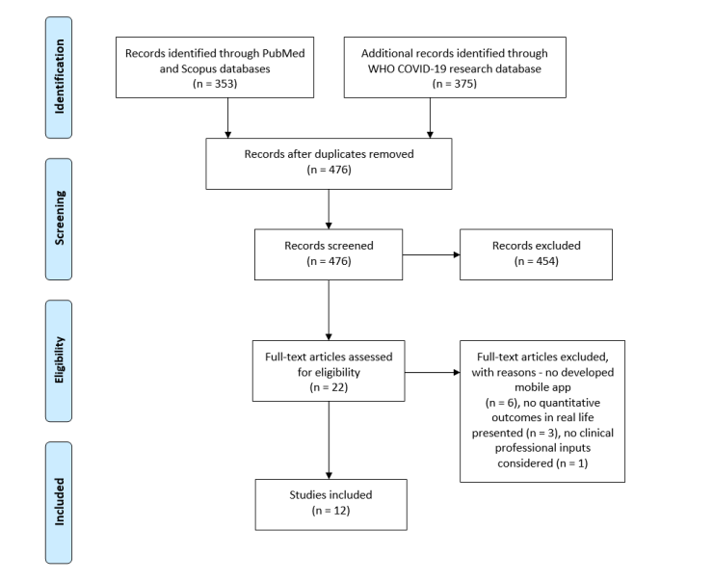

Fig:The PRISMA (Preferred Reporting Items for Systematic Reviews and Meta-Analyses) flow diagram. WHO: World Health Organization

**CHAPTER 3**

**SCOPE OF THE PROJECT**

**Chapter 3 : Scope of the Project**

**3.1 Background:**

Contact tracing is a widely adopted surveillance system that is used to identify, evaluate, and handle people who have been exposed to novel infectious diseases. The mobile phone apps using a digital technological system, called “proximity tracking,” is used as a surveillance system to control the COVID-19 pandemic. Objective: The aim of this review is to examine the use of mobile phone apps for contact tracing to control the COVID-19 pandemic worldwide. Method: A search of different electronic databases, such as PubMed, PubMed Central, Google Scholar, and Google, was carried out using search items ‘mobile app,’ ‘tracing’, and ‘COVID-19’. The search was conducted between 18 to 31 May 2020. Findings: The search revealed that a total of 15 countries in the world developed and actively using 17 mobile apps for contact tracing to control the COVID-19 pandemic during the selected time frame. China and Malaysia were only using two apps. Out of 17 apps, three were protected by the country’s data protection laws. The results indicate that the mobile apps were used to monitor self-isolated individuals, identify individuals not wearing masks, whether they had close contact with an infected person, provides exact time and place of the encounter, and possible risk of infection. Conclusion: Contact tracing is found to be an essential public health approach to fight the spread of COVID-19 pandemic and other novel infectious diseases. However, caution is warranted to generalize the usability of apps, especially in the LMICs, and to address the concerns regarding data anonymizing, data privacy and usage, and data rights.

The COVID-19 outbreak, which first emerged in China, has spread worldwide. On March 11, 2020, the World Health Organization (WHO) declared COVID-19 as a pandemic. The disease has disrupted global trade, employment, and travel, and many governments had to take strict measures to control the spread of the virus and minimize the burden of morbidity and mortality so that health care systems remain functional . In many countries around the world, citizens have been recommended to stay at home and practice social distancing for as long as possible as a primary measure of preventing the spread of COVID-19. Although mobile apps are successfully used for managing chronic diseases, the ongoing COVID-19 pandemic has pushed the need for mobile app solutions at the forefront to reduce the risk of cross-contamination caused by close contact. Mobile technology has been leveraged in a number of ways to control the spread of COVID-19. Mobile apps are accessible, acceptable, and easily adopted, and have the ability to support social distancing efforts. As such, they have been widely developed and implemented during the previous months

In an attempt to “flatten the curve” of the increasing number of COVID-19 cases, providing knowledge and information to civilians while attempting to relieve the pressure from health care systems. Despite increasing reliance on mobile health (mHealth) solutions as part of COVID-19–related response plans, major knowledge gaps exist about their utility and efficacy during the current pandemic for both health professionals as well as for the general population. To this direction, this systematic review aims to shed light into studies found in the scientific literature on the use and evaluation of mobile apps for the prevention, management, treatment, or follow-up of COVID-19. Other recent reviews have focused merely on the exploration of COVID-19 mobile apps in app stores in general or were restricted to apps deployed in specified countries such as the United States, the United Kingdom, and India . Although there are already related generic COVID-19 information and communication technology surveys they focus on specific topics such as contact tracing specialized health sectors like pediatric health care delivery, mental health [15], epilepsy and palliative care or countries like India China and the United Kingdom To the best of our knowledge, there has been no other work dedicated to the systematic review of pragmatic studies that have demonstrated the real-life use and evaluation of COVID-19 mobile apps.

**3.2 Study Selection**

The string “(mobile health) OR (mhealth) OR (smartphone) OR (mobile phone) OR (mobile application) OR (mobile app) OR (app) AND (COVID-19),” was used for a search within the title, abstract, and keywords of the manuscripts. We independently screened the identified papers to minimize possible errors and bias in the selection process. Any disagreements were resolved by discussion between the authors to reach consensus. The authors first screened the abstracts of the candidate papers for inclusion and assessed their eligibility according to the defined inclusion and exclusion criteria. Moreover, the authors selected the final papers for inclusion after reading the full manuscripts of the eligible papers, as well as their references. The Effective Public Health Practice Project (EPHPP) tool was adopted to assess the methodological quality of the included studies. The EPHPP tool is suitable for evaluating quantitative studies in a wide range of health-related topics, and it has demonstrated reliability. The included studies were synthesized according to their target, mobile app main features, study design, number of enrolled participants and their age, follow-up duration, outcomes and whether these were positive or negative, and implications for clinical practice. This systematic review was conducted following the PRISMA (Preferred Reporting Items for Systematic Reviews and Meta-Analyses) guidelines A completed PRISMA checklist is shown in above figures

**3.3 Mandatory application of contact tracing apps in East Asia**

Contact tracing apps can greatly support testing, tracing, isolating, and quarantine measures in the attempt to mitigate and slow the spread of the SARS-Cov-2 virus by speeding up processes of reporting and contact tracing through improved digital data flow, proximity tracing and geolocation tracking . It could play a pivotal role given the ubiquity of internet-connected devices and increase the speed of surveillance of a large population of smartphone users in almost real-time to know where the infection hotspots are. As lockdown measures are gradually being lifted in many countries, contact tracing apps are central to control strategies during the de-escalation of social distancing . It can also be crucial in flagging more infections especially in scenarios where manual contact tracing cannot. For example, a yet-to-be diagnosed person has the SARS-Cov-2 virus and takes a crowded bus to work; manual contact tracing is unlikely to identify everyone on the bus standing close to the infected person. Indeed, a study by Kucharski found that combined testing and contact tracing strategies significantly reduced the reproductive number more than mass testing or self-isolation alone.

In East Asian countries such as China and especially Taiwan, contact tracing apps have been mandatory and proved effective alongside manual contact tracing methods in identifying new cases since the end of lockdown . The apps generally work by assigning a colour code (green, yellow, or red) using an algorithmic assessment of the user’s travel history and health status. People who can show a green health code on their smartphones demonstrate they have not been in contact with a confirmed case of COVID-19 . In South Korea, contact tracing apps such as the ‘Corona 100’ seems to be popular and has enabled public health officials to reduce the time needed to trace a patient’s movements from around 24 h to approximately 10 min and thus, helped the general public avoid infectious areas.

South Korea’s extensive contact tracing, testing, and isolation measures received overwhelming support from the population and have helped to reduce the virus’s spread . Laws passed and data transparency during the MERS outbreak in 2015 allows the South Korean government to collect and publish public data including travel histories of confirmed patients. Hence, the privacy of the population has been given up to the government especially in response to public health safety. To ensure people under compulsory home quarantines do not stray from the confines of their apartments, the Hong Kong government required compulsory download of the ‘StayHomeSafe’ app and provided geofencing electronic tracker wristbands that alert authorities if they violated quarantines. These approaches have significantly contributed to the mass acceptance of contact tracing apps so far in the region.

There is little evidence to suggest that the use of these types of approaches adopted in East Asian countries might be successfully transferable to neo-liberal societies such as the USA, UK, France, Germany etc. with different political and cultural systems. Controversies about the legitimacy of these apps have largely focused on issues of privacy and surveillance as commentators emphasized the differences between populations in East Asia’s acceptance of state surveillance and a European scepticism towards this practice . The barrier appears to be that many of these countries especially in Europe are very sensitive to privacy issues and privacy is protected by law like the General Data Protection Regulation (GDPR) . A study by Hernandez-Orallo shows that for possible second waves of infection, contact tracing apps can be effective in controlling the SARS-Cov-2 virus, assuming that a percentage of the population will have gained immunity, or implemented in combination with some other lenient measures, such as social distancing. Moreover, for many of such countries that are resuming business operations and social activities, or where protests are happening and the number of social contacts increases, it will be worthwhile for them to invest in strategies to vastly improve the mass acceptance of contact-tracing apps to enable rapid response to a resurgence of the SARS-Cov-2 virus .However, the apparent dilemma faced by neo-liberal governments is making a conscious choice between privacy and public health whilst showing the efficacy of such apps.

**CHAPTER 4**

**METHODOLOGY**

**Chapter 4 : Methodology**

**4.1 Research methodology**

The systematic literature review (SLR) was conducted by searching databases of Google Scholar, Web of Science, PubMed, IEEE Xplore Digital Library, PsycInfo and ScienceDirect using the search terms (“Contact Tracing” OR “Contact Tracing apps”) AND (“COVID-19” OR “Coronavirus”) to identify relevant literature. The search strings were run against the title, keywords, and abstract, depending on the search platforms. The searches were conducted between January 1, 2020, through January 31, 2021. Further inputs were also taken from relevant preprints, published government and technical reports. Previous studies have used similar methods to conduct an SLR. To achieve the objectives of extensively reviewing the most relevant studies and answering the research questions. We conducted the SLR under the guidance published by Kitchenham and Charters. According to Kitchenham and Charters, a Systematic Literature Review is “a form of secondary study that uses a well-defined methodology to identify, analyse and interpret all available evidence related to a specific research question in a way that is unbiased and repeatable” . The SLR allows us to implement the three phases of planning the review, conducting the review, and reporting or documenting the review. Each phase of the SLR is outlined below:

**Planning the review involves the following steps:**

* Identification of the need for an extensive literature review
* Formulating the research questions
* Development of search strategy (this involves using search strings, sources selection, search processes and documenting search strategy).

**Conducting the review involves the following steps:**

* Selection of relevant publications (Inclusion and Exclusion Criteria)
* Evaluation and assessment of selected relevant publications
* Data extraction and synthesis-to address the research questions

**Reporting the review (Documentation) involves the following steps:**

* Presentation of results
* Discussion of findings based on the research questions

The phases of the SLR adopted to conduct this research is presented in Fig below

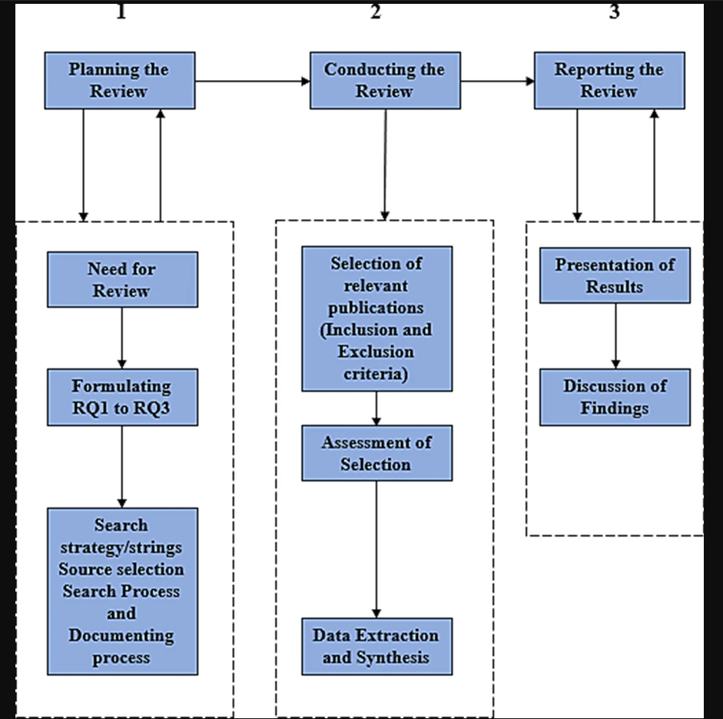IMG_256

**4.2 Planning the review**

The purpose of this SLR is to analyse current and existing studies and their findings and to summarize the current challenges in the application of contact tracing apps in the fight against the COVID-19 pandemic in neo-liberal societies. To make sure our study is focused, we developed three research questions as follows.

* What are the current challenges facing the efficacy and mass acceptance of contact tracing apps for COVID-19 in neo-liberal societies?
* What recommendations can be implemented to address these challenges and improve mass acceptance?
* What are the future directions and considerations in the use of digital contact tracing technologies in the fight against future pandemic outbreaks?

The study complements existing studies by conducting an SLR to identify the pressing challenges related to the adoption of contact tracing apps in the fight against COVID-19, a global pandemic that has claimed a significant number of human lives and caused major disruptions to business, led to social isolation and modified human relations in neo-liberal societies up to January 2021. It provides an up to date study and the current state of contact tracing apps in containing the spread of this deadly infectious disease. The study aims to present governments and policymakers with the challenges they face and discuss strategies they need to consider if the population are to adopt the use of contact tracing apps now and similar contact tracing technologies in future pandemic outbreaks.

### 4.3 Conducting the review

These searched were conducted on the 31st of January 2021. A total of 18,566 results were returned from the initial searches carried out using the search strings and keywords on the online digital databases. These results included a combination of peer-reviewed publications, preprints, and reports from credible sources. The results from these searches were filtered through the inclusion/exclusion criteria to remove irrelevant and duplicate publications. Moreover, we implemented forward and backward snowballing iterations to ensure that all the selected publications were relevant and met the inclusion criteria.

**These inclusion criteria were:**

* Selected publications must be relevant to contact tracing technology and its application in the fight against the COVID-19 pandemic.
* Publications must be related to the research questions (RQ1 to RQ3).
* Publications must be written in English.

**The exclusion criteria, on the other hand, were:**

* Publications not relevant to contact tracing technology and its application in the fight against the COVID-19 pandemic.
* Duplication of published sources, news articles and literature not written in English.

Since an SLR is about conducting a comprehensive search of all relevant sources related to the research topic, further checks using a quality assessment was applied for a more rigorous result. A detailed assessment of the selected publications was done based on the checklist as set by Kitchenham and Charters to determine their relevance and suitability for addition to the SLR. The quality assessment was based on the primary goal of the selected publication, context, and relevance to the stated research questions RQ1 to RQ3. We selected 5 publications at random and used the following quality assessment check for the final selection of publications. The publication must meet at least one or more following.

1. **Contact Tracing Apps.** The publication must include discussion and application of contact tracing apps in the fight against COVID-19.
2. **Context.** The content of the publication consists of relevant details which explain the objectives and findings.
3. **Challenges of Contact Tracing Apps.** The publication consists of some significant details on the challenges of digital contact tracing apps in the fight against COVID-19 to address RQ1.
4. **Recommendations.** The publication includes some recommendations to address challenges of digital contact tracing or the use of contact tracing apps in the fight against COVID-19 to address RQ2.
5. **Future Considerations.**The publication discusses future considerations in the implication or use of digital contact tracing technology in the fight against future pandemics to address RQ3.

With this process, 17,959 publications were excluded from the initial search results, bringing the total number down to 610 publications. Following that, the exclusion criteria based on titles, abstract and content was implemented; and as a result, 538 publications were also excluded altogether, bringing the number down to 72 relevant publications. Finally, 61 publications were identified as the final set of primary studies for this SLR after the quality assessment selection. Figure [2](https://link.springer.com/article/10.1007/s13755-021-00147-7#Fig2) shows the number of publications selected and excluded at each stage of the process. The data extracted from the collection of relevant publications were used to provide answers to the research questions RQ1 to RQ3 in line with the objectives of this study. The data extraction and synthesis for the final publications are described and categorized based on the following categories:

* **Context Data:** Details about the aim and purpose of the study.
* **Qualitative data:** Findings and conclusions from the relevant study.
* **Quantitative data**: Results from extracted data, discussions, and findings from the relevant study.

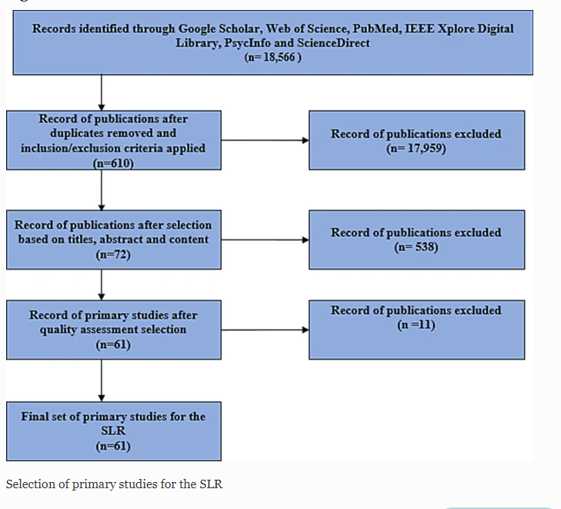

IMG_256IMG_256IMG_256

**CHAPTER 5**

**DESIGN, WORKING AND PROCESS**

**Chapter 5 : Design,Working & Process**

**5.1 COVID-19 Tracker:**

COVID-19 Tracker visualizes Global COVID-19 data.

It provides real-time tally of COVID-19 patients in India (Global data added in v1.1). It covers global level, nation level and state level (only for India) cases.A Mobile application to track the COVID-19 cases made using Kotlin. Complete applicaion with neat UI and full API Integration Thanks to COVID19India.org for open-source API.

**5.2 Features :**

* Real-time updates of global COVID-19 patients.
* State-wise and district-wise data available.
* Total number of tested people available (Source ICMR).
* Sorting of data available.
* Can check data for any previous date (India Dashboard Only).
* Graphical representation of total confirmed, recovered and deceased cases and state-wise graphical representation also available.
* Data represented through pie charts line charts and bar graphs for 14 days, 30 days and since the beginning.
* State-wise information of COVID-19 testing labs, Helpline numbers, Fundraisers and other public welfare organisations such as door-step delivery of essentials etc. available with their contact information.
* Growth Rate, Growth Factor, State-wise different statistics' graphical comparisons.
* Can compare spread trends of any two countries
* Zones information is provided for India, denoted by coloured dots
* Predictions using SIRD model of epidemiology
* Available languages: English(for now)
* Offline caching using Room persistance library (injected with Dagger2)
* Ability to pin specific countries (also using Room)
* Statewise data of Indian States (with sorting options)

**5.3 Disclaimer :**

COVID-19 Tracker does not collect any personal data, nor does it require access to Bluetooth, and is in no way meant to be an alternative to Aarogya Setu launched by Govt. of India. Aarogya Setu provides government guidelines to fight the pandemic and makes it easier to backtrack potential COVID-19 cases. It is strongly recommended that you download Aarogya Setu too.

**COVID-19 Tracker Android Application**

This application displays the latest updates based on numbers from <https://www.covid19india.org/>

**5.4 Technologies used :**

* Kotlin(https://kotlinlang.org/docs/native-libraries.html)
* Koin(https://insert-koin.io/)
* MVVM Architecture(https://github.com/MindorksOpenSource/android-mvvm-architecture)
* Material Design (https://material.io/develop/android/docs/getting-started)
* AndroidX(https://developer.android.com/jetpack/androidx)
* Kotlin Coroutines(https://kotlinlang.org/docs/coroutines-overview.html)
* Retrofit 2(https://square.github.io/retrofit/)
* Moshi JSON Parser (https://github.com/square/moshi)
* Android Architecture Component(https://developer.android.com/topic/libraries/architecture#:~:text=Android%20architecture%20components%20are%20a,the%20Guide%20to%20app%20architecture.)
* Github(to store our code)
* Windows 10(OS)
* Android Studio(IDLE)
* VS Code(code Development)

**5.4.1 Kotlin**



**What is Kotlin?**

Kotlin is a general purpose, free, open source, statically typed “pragmatic” programming language initially designed for the JVM (Java Virtual Machine) and Android that combines object-oriented and functional programming features. It is focused on interoperability, safety, clarity, and tooling support. Versions of Kotlin targeting JavaScript ES5.1 and native code (using LLVM) for a number of processors are in production as well.

Kotlin originated at JetBrains, the company behind IntelliJ IDEA, in 2010, and has been open source since 2012. The Kotlin team currently has more than 90 full-time members from JetBrains, and the [Kotlin project on GitHub](https://github.com/JetBrains/kotlin) has more than 300 contributors. JetBrains uses Kotlin in many of its products including its flagship IntelliJ IDEA.

At first glance, Kotlin looks like a more concise and streamlined version of Java. Consider the screenshot above, where I have [converted a Java code sample](https://try.kotlinlang.org/#/Kotlin Koans/Introduction/Java to Kotlin conversion/Task.kt) (at left) to Kotlin automatically. Notice that the mindless repetition inherent in instantiating Java variables has gone away. The Java idiom

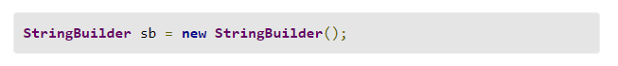Becomes in Kotlin

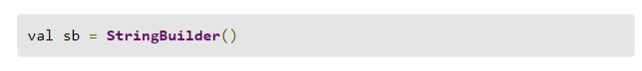

You can see that functions are defined with the fun keyword, and that semicolons are now optional when newlines are present. The val keyword declares a read-only property or local variable. Similarly, the var keyword declares a mutable property or local variable.

Nevertheless, Kotlin is strongly typed. The val and var keywords can be used only when the type can be inferred. Otherwise you need to declare the type. Type inference seems to be improving with each release of Kotlin.

Have a look at the function declaration near the top of both panes. The return type in Java precedes the prototype, but in Kotlin it succeeds the prototype, demarcated with a colon as in Pascal.

[ JavaScript is the most widely deployed language in the world. Whether you're a beginning, intermediate, or advanced JavaScript developer, you'll master new skills with[this nine-part course from PluralSight.](https://pluralsight.pxf.io/c/321564/424552/7490?u=https://www.pluralsight.com/paths/javascript) ]

It is not completely obvious from this example, but Kotlin has relaxed Java’s requirement that functions be class members. In Kotlin, functions may be declared at top level in a file, locally inside other functions, as a member function inside a class or object, and as an extension function. Extension functions provide the C#-like ability to extend a class with new functionality without having to inherit from the class or use any type of design pattern such as Decorator.

For Groovy fans, Kotlin implements builders; in fact, Kotlin builders can be type checked. Kotlin supports delegated properties, which can be used to implement lazy properties, observable properties, vetoable properties, and mapped properties.

Many asynchronous mechanisms available in other languages can be implemented as libraries using Kotlin coroutines. This includes async/await from C# and ECMAScript, channels and select from Go, and generators/yield from C# and Python.

Up until May 2017, the only officially supported programming languages for Android were Java and C++. [Google announced official support for Kotlin on Android](https://www.youtube.com/watch?v=NqlRg1_bCC4) at Google I/O 2017, and starting with Android Studio 3.0 [Kotlin is built into the Android development toolset](https://developer.android.com/kotlin/index.html). Kotlin can be added to earlier versions of Android Studio with a plug-in.

Kotlin compiles to the same byte code as Java, interoperates with Java classes in natural ways, and shares its tooling with Java. Because there is no overhead for calling back and forth between Kotlin and Java, adding Kotlin incrementally to an Android app currently in Java makes perfect sense. The few cases where the interoperability between Kotlin and Java code lacks grace, such as Java set-only properties, are rarely encountered and easily fixed.

[Pinterest was the poster child for Android apps written in Kotlin](https://www.youtube.com/watch?v=mDpnc45WwlI) as early as November 2016, and it was mentioned prominently at Google I/O 2017 as part of the Kotlin announcement. In addition, the Kotlin team likes to cite the Evernote, Trello, Square, and Coursera apps for Android.

**5.4.2 Koin**



**What is Koin?**

Koin is a DI framework for Kotlin developers, completely written in Kotin.

It is very light weighted. It supports the Kotlin DSL feature. It is one of the easy DI frameworks which doesn't require a steep learning curve to get hold of it.

**Understanding Terminologies in Koin**

While working with Koin, there are few terminologies we need to understand before getting started.

**module** - it creates a module in Koin which would be used by Koin to provide all the dependencies.

**single** - it creates a singleton that can be used across the app as a singular instance.

factory - it provides a bean definition, which will create a new instance each time it is injected.

**get()** - it is used in the constructor of a class to provide the required dependency.

**5.4.3 MVVM Architecture**

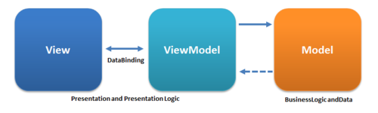

Developers always prefer a clean and structured code for the projects. By organizing the codes according to a design pattern helps in the maintenance of the software. By having knowledge of all crucial logic parts of the [android](https://www.geeksforgeeks.org/kotlin-android-tutorial/) application, it is easier to add and remove app features. Further, design patterns also assure that all the codes get covered in Unit Testing without the interference of other classes. Model — View — ViewModel (MVVM) is the industry-recognized software [architecture pattern](https://www.geeksforgeeks.org/android-architecture-patterns/) that overcomes all drawbacks of MVP and [MVC](https://www.geeksforgeeks.org/mvc-model-view-controller-architecture-pattern-in-android-with-example/) design patterns. MVVM suggests separating the data presentation logic(Views or UI) from the core business logic part of the application.

The separate code layers of MVVM are:

Model: This layer is responsible for the abstraction of the data sources. Model and ViewModel work together to get and save the data.

View: The purpose of this layer is to inform the ViewModel about the user’s action. This layer observes the ViewModel and does not contain any kind of application logic.

ViewModel: It exposes those data streams which are relevant to the View. Moreover, it servers as a link between the Model and the View.

MVVM pattern has some similarities with the MVP(Model — View — Presenter) design pattern as the Presenter role is played by ViewModel. However, the drawbacks of the MVP pattern has been solved by MVVM in the following ways:

1. ViewModel does not hold any kind of reference to the View.
2. Many to 1 relationship exist between View and ViewModel.
3. No triggering methods to update the View

.

**Ways to Implement MVVM in the Project**

There are 2 ways to implement MVVM design pattern in Android projects:

Using the DataBinding library released by Google

Using any tool like RxJava for DataBinding.

**Rationale**

MVVM was designed to remove virtually all [GUI](https://en.wikipedia.org/wiki/Graphical_user_interface) code ("[code-behind](https://en.wikipedia.org/wiki/Code-behind)") from the view layer, by using [data binding](https://en.wikipedia.org/wiki/Data_binding) functions in WPF (Windows Presentation Foundation) to better facilitate the separation of view layer development from the rest of the pattern. Instead of requiring [user experience](https://en.wikipedia.org/wiki/User_experience_design) (UX) developers to write GUI code, they can use the framework markup language (e.g., [XAML](https://en.wikipedia.org/wiki/Extensible_Application_Markup_Language)) and create data bindings to the view model, which is written and maintained by application developers. The separation of roles allows interactive designers to focus on UX needs rather than programming of business logic. The layers of an application can thus be developed in multiple work streams for higher productivity. Even when a single developer works on the entire code base, a proper separation of the view from the model is more productive, as the user interface typically changes frequently and late in the development cycle based on end-user feedback.[[citation needed](https://en.wikipedia.org/wiki/Wikipedia:Citation_needed)]

The MVVM pattern attempts to gain both advantages of separation of functional development provided by MVC, while leveraging the advantages of [data bindings](https://en.wikipedia.org/wiki/Data_binding) and the framework by binding data as close to the pure application model as possible.It uses the binder, view model, and any business layers' data-checking features to validate incoming data. The result is that the model and framework drive as much of the operations as possible, eliminating or minimizing application logic which directly manipulates the view (e.g., code-behind).

**5.4.4 Material Design**



**Overview**

The main purpose of material design is creation of new visual language that combines principles of [good design](https://en.wikipedia.org/wiki/Visual_design_elements_and_principles) with technical and scientific innovation. Designer [Matías Duarte](https://en.wikipedia.org/wiki/Mat%C3%ADas_Duarte) explained that, "unlike real paper, our digital material can expand and reform intelligently. Material has physical surfaces and edges. Seams and shadows provide meaning about what you can touch." Google states that their new design language is based on paper and ink but implementation takes place in an advanced manner.

In 2018, Google detailed a revamp of the language, with a focus on providing more flexibility for designers to create custom "themes" with varying geometry, colors, and typography. Google released Material Theme Editor exclusively for the [macOS](https://en.wikipedia.org/wiki/MacOS) design application [Sketch](https://en.wikipedia.org/wiki/Sketch_(software)).

**Implementation**

Material Design was to be gradually extended throughout Google's array of web and mobile products, providing a consistent experience across all platforms and applications. Google has also released [application programming interfaces](https://en.wikipedia.org/wiki/Application_programming_interface) (APIs) for third-party developers to incorporate the design language into their applications.

After the 2018 revamp, Google began redesigning most of their apps into a customized and adapted version of Material Design called the Google Material Theme, also dubbed "Material Design 2", which heavily emphasizes white space, rounded corners, colorful icons, bottom navigation bars, and utilizes a special size-condensed version of Google's proprietary [Product Sans](https://en.wikipedia.org/wiki/Product_Sans) font called Google Sans. When unveiling Android 12 in May 2021, Google unveiled a concept known as "Material You", emphasizing increased animation, larger buttons, and the ability for custom UI themes to be generated from the user's wallpaper.

The [canonical implementation](https://en.wikipedia.org/wiki/Canonicalization) of Material Design for web application user interfaces is called [Polymer](https://en.wikipedia.org/wiki/Polymer_(library)). It consists of the Polymer library, a [shim](https://en.wikipedia.org/wiki/Shim_(computing)) that provides a [Web Components](https://en.wikipedia.org/wiki/Web_Components) API for browsers that do not implement the standard natively, and an elements catalog, including the "paper elements collection" that features visual elements of the Material Design. Google also has created an accompanying icon set licensed under the Apache 2.0 license.

**5.4.5 Android X**



Artifacts within the androidx namespace comprise the [Android Jetpack](https://developer.android.com/jetpack) libraries. Like the Support Library, libraries in the androidx namespace ship separately from the Android platform and provide backward compatibility across Android releases.

AndroidX is a major improvement to the original Android [Support Library](https://developer.android.com/topic/libraries/support-library), which is no longer maintained. androidx packages fully replace the Support Library by providing feature parity and new libraries.

In addition, AndroidX includes the following features:

* All packages in AndroidX live in a consistent namespace starting with the string androidx. The Support Library packages have been mapped into corresponding androidx.\* packages. For a full mapping of all the old classes and build artifacts to the new ones, see the [Package Refactoring](https://developer.android.com/jetpack/androidx/refactor) page.
* Unlike the Support Library, androidx packages are separately maintained and updated. The androidx packages use strict [Semantic Versioning](https://semver.org/), starting with version 1.0.0. You can update AndroidX libraries in your project independently.
* [Version 28.0.0](https://developer.android.com/topic/libraries/support-library/revisions#28-0-0) is the last release of the Support Library. There will be no more android.support library releases. All new feature development will be in the androidx namespace.

**Using androidx libraries in your project**

See [Migrating to AndroidX](https://developer.android.com/jetpack/androidx/migrate) to learn how to migrate an existing project.

If you want to use androidx-namespaced libraries in a new project, you need to set the compile SDK to Android 9.0 (API level 28) or higher and set both of the following Android Gradle plugin flags to true in your [gradle.properties](https://developer.android.com/studio/build#properties-files) file.

android.useAndroidX: When this flag is set to true, the Android plugin uses the appropriate AndroidX library instead of a Support Library. The flag is false by default if it is not specified.

android.enableJetifier: When this flag is set to true, the Android plugin automatically migrates existing third-party libraries to use AndroidX dependencies by rewriting their binaries. The flag is false by default if it is not specified.

**API Reference**

All the packages and classes in the androidx namespace can be found in the [AndroidX reference section](https://developer.android.com/reference/androidx/packages).

**5.4.6 Retrofit 2**

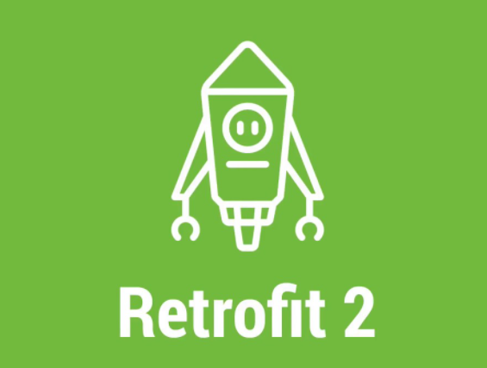

**Overview**

[Retrofit](http://square.github.io/retrofit/) is a type-safe REST client for Android, Java and Kotlin developed by Square. The library provides a powerful framework for authenticating and interacting with APIs and sending network requests with [OkHttp](http://square.github.io/okhttp/). See [this guide](https://guides.codepath.com/android/Using-OkHttp) to understand how OkHttp works.

This library makes downloading JSON or XML data from a web API fairly straightforward. Once the data is downloaded then it is parsed into a Plain Old Java Object (POJO) which must be defined for each "resource" in the response

**5.4.7 Moshi JSON Parser**



[Moshi](https://github.com/square/moshi) is a modern JSON library for Android and Java from Square. It can be considered as the successor to GSON, with a simpler and leaner API and an architecture enabling better performance through the use of the [Okio](https://github.com/square/okio) library. It’s also the most Kotlin-friendly library you can use to parse JSON files, as it comes with Kotlin-aware extensions.

In this article I’m going to demonstrate how to take advantage of features from both the Moshi library and the Kotlin language itself in order to write efficient and robust JSON parsers.

**5.4.8 Android Architecture Component**

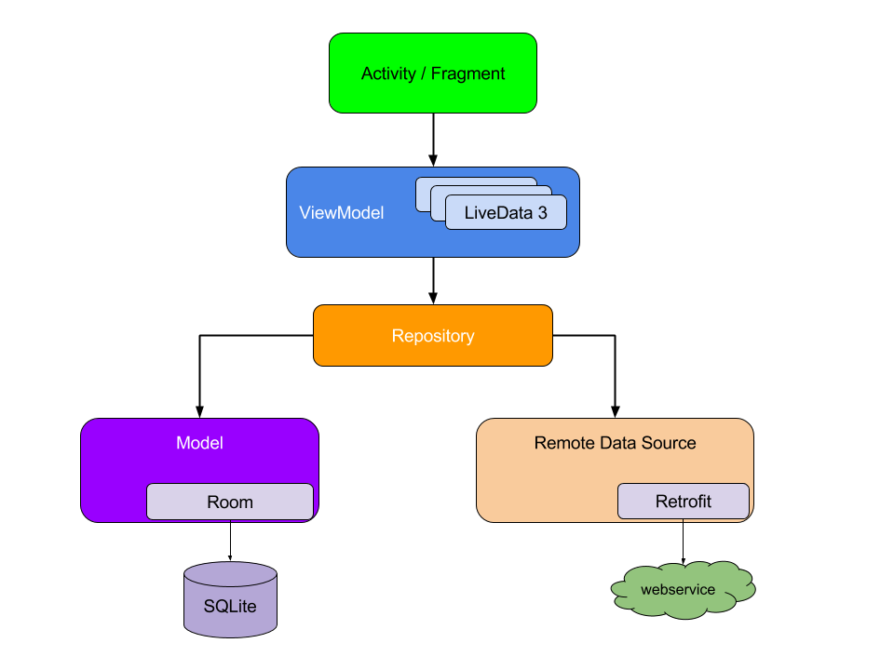

Android Architecture Components are a part of [Android Jetpack](https://blog.mindorks.com/what-is-android-jetpack-and-why-should-we-use-it).

As the [Android Jetpack](https://blog.mindorks.com/what-is-android-jetpack-and-why-should-we-use-it) components are a collection of libraries that are individually adoptable and built to work together while taking advantage of Kotlin language features that make us more productive.

These software components have been arranged in 4 categories in which one of the categories is Architecture Components. Other categories are Foundation Components, Behavior Components and UI Components.

Android architecture components are a collection of libraries that help us in the following:

* Building the robust Android application.
* Building the testable Android application.
* Building the maintainable Android Apps.

Architecture components help in managing our UI component lifecycle and handling data persistence.

All the Android Architecture Components are as follows:

[**Data Binding**](https://developer.android.com/topic/libraries/data-binding/): It helps in declaratively binding UI elements to in our layout to data sources of our app.

[**Lifecycles**](https://developer.android.com/topic/libraries/architecture/lifecycle): It manages activity and fragment lifecycles of our app, survives configuration changes, avoids memory leaks and easily loads data into our UI.

[**LiveData**](https://developer.android.com/topic/libraries/architecture/livedata): It notifies views of any database changes. Use [LiveData](https://developer.android.com/topic/libraries/architecture/livedata) to build data objects that notify views when the underlying database changes.

[**Navigation**](https://developer.android.com/topic/libraries/architecture/navigation/): It handles everything needed for in-app navigation in Android application.

[**Paging**](https://developer.android.com/topic/libraries/architecture/paging/): It helps in gradually loading information on demand from our data source.

[**Room**](https://blog.mindorks.com/android-room-persistence-library-in-kotlin): It is a SQLite object mapping library. Use it to Avoid boilerplate code and easily convert SQLite table data to Java objects. Room provides compile time checks of SQLite statements and can return RxJava, Flowable and LiveData observables.

[**ViewModel**](https://developer.android.com/topic/libraries/architecture/viewmodel): It manages UI-related data in a lifecycle-conscious way. It stores UI-related data that isn't destroyed on app rotations.

[**WorkManager**](https://developer.android.com/topic/libraries/architecture/workmanager/): It manages every background jobs in Android with the circumstances we choose.

**5.4.9 Github**



GitHub, Inc. is a provider of [Internet hosting](https://en.wikipedia.org/wiki/Internet_hosting_service) for [software development](https://en.wikipedia.org/wiki/Software_development) and [version control](https://en.wikipedia.org/wiki/Version_control) using [Git](https://en.wikipedia.org/wiki/Git). It offers the [distributed version control](https://en.wikipedia.org/wiki/Distributed_version_control) and [source code management](https://en.wikipedia.org/wiki/Source_code_management) (SCM) functionality of Git, plus its own features. It provides [access control](https://en.wikipedia.org/wiki/Access_control) and several collaboration features such as [bug tracking](https://en.wikipedia.org/wiki/Bug_tracking_system), [feature](https://en.wikipedia.org/wiki/Software_feature) requests, [task management](https://en.wikipedia.org/wiki/Task_management), [continuous integration](https://en.wikipedia.org/wiki/Continuous_integration) and [wikis](https://en.wikipedia.org/wiki/Wiki) for every project. Headquartered in [California](https://en.wikipedia.org/wiki/California), it has been a subsidiary of [Microsoft](https://en.wikipedia.org/wiki/Microsoft) since 2018.

GitHub offers its basic services free of charge. Its more advanced professional and enterprise services are commercial.[[6]](https://en.wikipedia.org/wiki/GitHub#cite_note-6) Free GitHub accounts are commonly used to host [open-source](https://en.wikipedia.org/wiki/Open-source) projects.As of January 2019, GitHub offers unlimited private [repositories](https://en.wikipedia.org/wiki/Repository_(version_control)) to all plans, including free accounts, but allowed only up to three collaborators per repository for free.[[8]](https://en.wikipedia.org/wiki/GitHub#cite_note-8) Starting from April 15, 2020, the free plan allows unlimited collaborators, but restricts private repositories to 2,000 minutes of GitHub Actions[[9]](https://en.wikipedia.org/wiki/GitHub#cite_note-9) per month. As of January 2020, GitHub reports having over 40 million users and more than 190 million [repositories](https://en.wikipedia.org/wiki/Repository_(version_control)) (including at least 28 million public repositories), making it the largest host of [source code](https://en.wikipedia.org/wiki/Source_code) in the world

**5.4.10 Windows 10**



Windows 10 is a major version of the Microsoft Windows operating system that was released on July 29, 2015. It is built on the Windows NT kernel and follows Windows 8. Part of the reason Microsoft decided to name the 2015 release "Windows 10" (and skipped "Windows 9") is because the operating system is designed to be a new direction for Microsoft. One of the primaries aims of Windows 10 is to unify the Windows experience across multiple devices, such desktop computers, tablets, and smartphones. As part of this effort, Microsoft developed Windows 10 Mobile alongside Windows 10 to replaces Windows Phone – Microsoft's previous mobile OS. Windows 10 also integrates other Microsoft services, such as Xbox Live and the Cortana voice recognition assistant. While Windows 10 includes many new features, it also brings back the Start Menu, which was dropped in Windows 8. The new and improved Start Menu provides quick access to settings, folders, and programs and also includes tiles from the Windows 8 interface. The bottom of the Windows 10 Start Menu includes a search bar that allows you to search both your local PC and the web. 31 Another major change in Windows 10 is the introduction of the "Edge" web browser, which is designed to replace Internet Explorer (IE). While the OS still includes IE, Edge is the default browser in Windows 10. Other new features include Continuum, which automatically optimizes the user interface depending on whether you are using an external keyboard or touchscreen, and Action Center, which is similar to the Notifications bar in OS X. Windows 10 also supports multiple desktops on a single monitor and provides Snap Assist, a feature that helps organize windows on the screen **Features of Windows 10**

Windows 10 released with mostly positive reviews upon its original announcement in July 2015; detractors praised Microsoft's decision to downplay user-interface mechanics introduced by Windows 8 (including the full-screen apps and Start screen). Here are the best features of the operating system.

**It's free**

One of the best new growth in Windows 10 is that it is completely free to upgrade. Microsoft made this declare at its January event in Redmond. The steady has said it will be available at no charge for the first year for Windows 8.1 and Windows Phone 8.1 users. It will also be free if you are still running Windows 7.

**Start Menu**

As we know that previous to the January meeting, Windows 10 will mark the return of the muchloved Start Menu. In the latest build shown, it has some updated graphics and can optionally go Fullscreen. In this feature half of the menu looks pretty much like it did in Windows 7

**Snap Assist helps you snap windows**

A new feature is Snap Assist that helps users work out, you need to do is to drag the title bar to the edge of the screen. Snap has been already available in previous versions of windows, but some features have been added. Drag the title bar to the edge top of the screen maximum window. You can drag the left or right edge of the screen to snap the application to the right or left.

**Cortana**

Cortana is a new feature of Windows 10. It is a voice-activated personal associate. We can use it to set reminders, get weather forecasts, tell you jokes, send an email, find files, and search the Internet and so on. The digital associate, that rivals Google Now, has been available on Windows Phone for a while will come to PCs and tablets. To get started, type a question in the search box on the taskbar. Or select the microphone icon and talk to Cortana. 32

**Settings App vs. Control Panel**

In the start menu of the setting option, you can take straight to the new setting app that is involved from the PC setting app on windows 8. This is a more user-friendly way to arrange your computer. However, it does not contain every system. The old control panel window is still included. It’s also available in the old control panel window.

**Desktop and Security Improvements**

There are still many desktop security improvements to do in windows 8, but we have not seen them if we have used windows 7. Microsoft gives the features of upgraded task manager, it’s so easier to what’s requirements resources of your system and even manages a startup program without third party software. Windows 10 includes Windows Defender by default, Window Defender is just changed the version of Microsoft Security Essentials. Window Defender has antivirus protection to safe your system.

**5.4.11 VS Code**



Visual Studio Code is a [source-code editor](https://en.wikipedia.org/wiki/Source-code_editor) made by [Microsoft](https://en.wikipedia.org/wiki/Microsoft) for [Windows](https://en.wikipedia.org/wiki/Windows), [Linux](https://en.wikipedia.org/wiki/Linux) and [macOS](https://en.wikipedia.org/wiki/MacOS). Features include support for [debugging](https://en.wikipedia.org/wiki/Debugging), [syntax highlighting](https://en.wikipedia.org/wiki/Syntax_highlighting), [intelligent code completion](https://en.wikipedia.org/wiki/Intelligent_code_completion), [snippets](https://en.wikipedia.org/wiki/Snippet_(programming)), [code refactoring](https://en.wikipedia.org/wiki/Code_refactoring), and embedded [Git](https://en.wikipedia.org/wiki/Git). Users can change the [theme](https://en.wikipedia.org/wiki/Theme_(computing)), [keyboard shortcuts](https://en.wikipedia.org/wiki/Keyboard_shortcut), preferences, and install [extensions](https://en.wikipedia.org/wiki/Plug-in_(computing)) that add additional functionality.

Microsoft has released most of Visual Studio Code's [source code](https://en.wikipedia.org/wiki/Source_code) on the microsoft/vscode repository of [GitHub](https://en.wikipedia.org/wiki/GitHub) using the "Code – OSS" name, under the permissive [MIT License](https://en.wikipedia.org/wiki/MIT_License), while the releases by Microsoft are proprietary [freeware](https://en.wikipedia.org/wiki/Freeware).

In the [Stack Overflow](https://en.wikipedia.org/wiki/Stack_Overflow) 2019 Developer Survey, Visual Studio Code was ranked the most popular developer environment tool, with 50.7% of 87,317 respondents reporting that they use it.

Visual Studio Code was first announced on April 29, 2015, by Microsoft at the 2015 [Build](https://en.wikipedia.org/wiki/Build_(developer_conference)) conference. A Preview build was released shortly thereafter.

On November 18, 2015, Visual Studio Code was released under the [MIT License](https://en.wikipedia.org/wiki/MIT_License), having its source code available on [GitHub](https://en.wikipedia.org/wiki/GitHub). Extension support was also announced. On April 14, 2016, Visual Studio Code graduated from the [public preview](https://en.wikipedia.org/wiki/Beta_software) stage and was [released to the Web](https://en.wikipedia.org/wiki/Software_release_life_cycle#Web_release)

**Features**

[](https://en.wikipedia.org/wiki/File:Visual_Studio_Code_Insiders_1.36_icon.svg)

Visual Studio Code Insiders logo

Visual Studio Code is a source-code editor that can be used with a variety of programming languages, including [Java](https://en.wikipedia.org/wiki/Java_(programming_language)), [JavaScript](https://en.wikipedia.org/wiki/JavaScript), [Go](https://en.wikipedia.org/wiki/Go_(programming_language)), [Node.js](https://en.wikipedia.org/wiki/Node.js), [Python](https://en.wikipedia.org/wiki/Python_(programming_language)) and [C++](https://en.wikipedia.org/wiki/C++). It is based on the [Electron](https://en.wikipedia.org/wiki/Electron_(software_framework)) framework,[[19]](https://en.wikipedia.org/wiki/Visual_Studio_Code#cite_note-ars-electron-19) which is used to develop [Node.js](https://en.wikipedia.org/wiki/Node.js) [Web applications](https://en.wikipedia.org/wiki/Web_application) that run on the [Blink layout engine](https://en.wikipedia.org/wiki/Blink_layout_engine). Visual Studio Code employs the same editor component (codenamed "Monaco") used in [Azure DevOps](https://en.wikipedia.org/wiki/Azure_DevOps_Server) (formerly called Visual Studio Online and Visual Studio Team Services).

Instead of a project system, it allows users to open one or more directories, which can then be saved in workspaces for future reuse. This allows it to operate as a [language-agnostic](https://en.wikipedia.org/wiki/Language-agnostic) code editor for any language. It supports a number of programming languages and a set of features that differs per language. Unwanted files and folders can be excluded from the project tree via the settings. Many Visual Studio Code features are not exposed through menus or the user interface but can be accessed via the command palette.

Visual Studio Code can be extended via [extensions](https://en.wikipedia.org/wiki/Plug-in_(computing)), available through a central repository. This includes additions to the editor and language support A notable feature is the ability to create extensions that add support for new [languages](https://en.wikipedia.org/wiki/Programming_language), [themes](https://en.wikipedia.org/wiki/Theme_(computing)), and [debuggers](https://en.wikipedia.org/wiki/Debugger), perform [static code analysis](https://en.wikipedia.org/wiki/Static_code_analysis), and add [code linters](https://en.wikipedia.org/wiki/Lint_(software)) using the [Language Server Protocol](https://en.wikipedia.org/wiki/Language_Server_Protocol).

Visual Studio Code includes multiple extensions for [FTP](https://en.wikipedia.org/wiki/FTP), allowing the software to be used as a free alternative for web development. Code can be synced between the editor and the server, without downloading any extra software.

Visual Studio Code allows users to set the [code page](https://en.wikipedia.org/wiki/Code_page) in which the active document is saved, the [newline](https://en.wikipedia.org/wiki/Newline) character, and the programming language of the active document. This allows it to be used on any platform, in any locale, and for any given programming language.

**Language support**

Out-of-the-box, Visual Studio Code includes basic support for most common programming languages. This basic support includes [syntax highlighting](https://en.wikipedia.org/wiki/Syntax_highlighting), [bracket matching](https://en.wikipedia.org/wiki/Bracket_matching), [code folding](https://en.wikipedia.org/wiki/Code_folding), and configurable snippets. Visual Studio Code also ships with [IntelliSense](https://en.wikipedia.org/wiki/Intelligent_code_completion) for JavaScript, TypeScript, [JSON](https://en.wikipedia.org/wiki/JSON), [CSS](https://en.wikipedia.org/wiki/CSS), and [HTML](https://en.wikipedia.org/wiki/HTML), as well as debugging support for Node.js. Support for additional languages can be provided by freely available extensions on the VS Code Marketplace.

**Data collection**

Visual Studio Code [collects usage data and sends it to Microsoft](https://en.wikipedia.org/wiki/Telemetry#Software), although this can be disabled. In addition, because of the open-source nature of the application, the telemetry code is accessible to the public, who can see exactly what is collected. According to Microsoft, the data is shared with Microsoft-controlled affiliates and subsidiaries, although [law enforcement](https://en.wikipedia.org/wiki/Law_enforcement) may request it as part of a legal process.

**Version control**

[Source control](https://en.wikipedia.org/wiki/Source_control) is a built-in feature of Visual Studio Code. It has a dedicated tab inside of the menu bar where you can access version control settings and view changes made to the current project. To use the feature you must link Visual Studio Code to any supported version control system ([Git](https://en.wikipedia.org/wiki/Git), [Apache Subversion](https://en.wikipedia.org/wiki/Apache_Subversion), [Perforce](https://en.wikipedia.org/wiki/Perforce), etc.). This allows you to create repositories as well as make push and [pull requests](https://en.wikipedia.org/wiki/Pull_request) directly from the Visual Studio Code program

**5.4.12 Android Studio**



Android Studio is the official [integrated development environment](https://en.wikipedia.org/wiki/Integrated_development_environment) (IDE) for [Google](https://en.wikipedia.org/wiki/Google)'s [Android](https://en.wikipedia.org/wiki/Android_(operating_system)) [operating system](https://en.wikipedia.org/wiki/Operating_system), built on [JetBrains](https://en.wikipedia.org/wiki/JetBrains)' [IntelliJ IDEA](https://en.wikipedia.org/wiki/IntelliJ_IDEA) software and designed specifically for [Android development](https://en.wikipedia.org/wiki/Android_software_development). It is available for download on [Windows](https://en.wikipedia.org/wiki/Windows), [macOS](https://en.wikipedia.org/wiki/MacOS) and [Linux](https://en.wikipedia.org/wiki/Linux) based operating systems or as a subscription-based service in 2020. It is a replacement for the [Eclipse Android Development Tools](https://en.wikipedia.org/wiki/Eclipse_(software)#Android_Development_Tools) (E-ADT) as the primary IDE for native Android application development.

Android Studio was announced on May 16, 2013 at the [Google I/O](https://en.wikipedia.org/wiki/Google_I/O) conference. It was in early access preview stage starting from version 0.1 in May 2013, then entered beta stage starting from version 0.8 which was released in June 2014. The first stable build was released in December 2014, starting from version 1.0.

On May 7, 2019, [Kotlin](https://en.wikipedia.org/wiki/Kotlin_(programming_language)) replaced [Java](https://en.wikipedia.org/wiki/Java_(programming_language)) as Google's preferred language for Android app development. Java is still supported, as is [C++](https://en.wikipedia.org/wiki/C++).

**Features**

A specific feature of the Android Studio is an absence of the possibility to switch autosave feature off.

The following features are provided in the current stable version:

* [Gradle](https://en.wikipedia.org/wiki/Gradle)-based build support
* Android-specific [refactoring](https://en.wikipedia.org/wiki/Code_refactoring) and quick fixes
* [Lint](https://en.wikipedia.org/wiki/Lint_(software)) tools to catch performance, usability, version compatibility and other problems
* [ProGuard](https://en.wikipedia.org/wiki/ProGuard_(software)) integration and app-signing capabilities
* Template-based wizards to create common Android designs and components
* A rich [layout editor](https://en.wikipedia.org/wiki/Graphical_user_interface_builder) that allows users to drag-and-drop UI components, option to [preview layouts](https://en.wikipedia.org/wiki/WYSIWYG) on multiple screen configurations
* Support for building [Android Wear](https://en.wikipedia.org/wiki/Android_Wear) apps
* Built-in support for Google Cloud Platform, enabling integration with Firebase Cloud Messaging (Earlier 'Google Cloud Messaging') and Google App Engine
* Android Virtual Device (Emulator) to run and debug apps in the Android studio.

Android Studio supports all the same programming languages of [IntelliJ](https://en.wikipedia.org/wiki/IntelliJ) (and [CLion](https://en.wikipedia.org/wiki/CLion)) e.g. [Java](https://en.wikipedia.org/wiki/Java_(programming_language)), [C++](https://en.wikipedia.org/wiki/C++), and more with extensions, such as [Go](https://en.wikipedia.org/wiki/Go_(programming_language)); and Android Studio 3.0 or later supports [Kotlin](https://en.wikipedia.org/wiki/Kotlin_(programming_language))[[21]](https://en.wikipedia.org/wiki/Android_Studio#cite_note-21) and "all Java 7 language features and a subset of Java 8 language features that vary by platform version." External projects [backport](https://en.wikipedia.org/wiki/Backporting) some Java 9 features. While IntelliJ states that Android Studio supports all released Java versions, and Java 12, it's not clear to what level Android Studio supports Java versions up to Java 12 (the documentation mentions partial Java 8 support). At least some new language features up to Java 12 are usable in Android.

Once an app has been compiled with Android Studio, it can be published on the [Google Play Store](https://en.wikipedia.org/wiki/Google_Play_Store). The application has to be in line with the Google Play Store [developer content policy](https://play.google.com/about/developer-content-policy/)

**Version history**

The following is a list of Android Studio's major releases

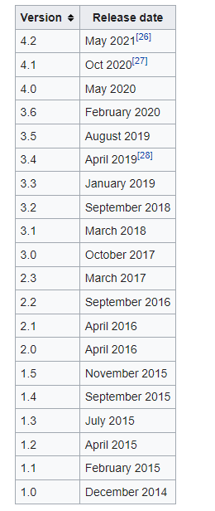

**System requirements**

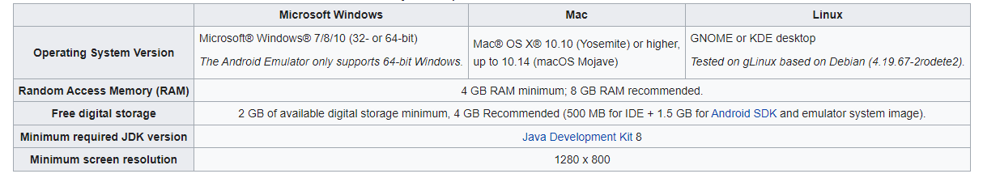

The Android Emulator has additional requirements beyond the basic system requirements for Android Studio, which are described below

SDK Tools 26.1.1 or higher;

64-bit processor;

Windows: CPU with UG (unrestricted guest) support;

Intel Hardware Accelerated Execution Manager (HAXM) 6.2.1 or later (HAXM 7.2.0 or later recommended).

The use of hardware acceleration has additional requirements on Windows and Linux:

Intel processor on Windows or Linux: Intel processor with support for Intel VT-x, Intel EM64T (Intel 64), and Execute Disable (XD) Bit functionality;

AMD processor on Linux: AMD processor with support for AMD Virtualization (AMD-V) and [Supplemental Streaming SIMD Extensions 3 (SSSE3)](https://en.wikipedia.org/wiki/SSSE3);

AMD processor on Windows: Android Studio 3.2 or higher and Windows 10 April 2018 release or higher for [Windows Hypervisor Platform (WHPX)](https://docs.microsoft.com/en-us/virtualization/api/) functionality.

To work with Android 8.1 (API level 27) and higher system images, an attached webcam must have the capability to capture 720p frames.

**5.5 Design:**

Last year, software designers took on an unprecedented challenge by facing [COVID-19](https://news.sap.com/covid-19/) head on with the creation of the [Corona-Warn-App](https://apps.apple.com/de/app/corona-warn-app/id1512595757), a consumer-based application that supports contact tracing for one of the biggest health crises of the 21st century.

The team learned to quickly juggle multiple expectations and requirements, drown out unnecessary noise, and focus on the “critical few” in order to create something highly usable and impactful.

With six weeks from design to delivery, here are their stories.

**5.6 From Design Idea to User Testing**

The initial design idea featured a simplified user experience with a very clear information architecture. It also imagined using elegant and modern illustrations along with descriptive text to facilitate onboarding and to provide users with end-to-end guidance throughout the application.

The goal was to find a design that was as usable and inclusive as possible.We’ve focused on the user experience as you interact with the app at a time full of uncertainty, emotions and anxiety. We wanted to provide helpful suggestions to help nudge the app to make it more:  
  
- Calm  
- Human  
- Empathetic  
- Delightful  
- Community focused

Thanks to The Ministry of Health & welfare for the Data(mohfw):

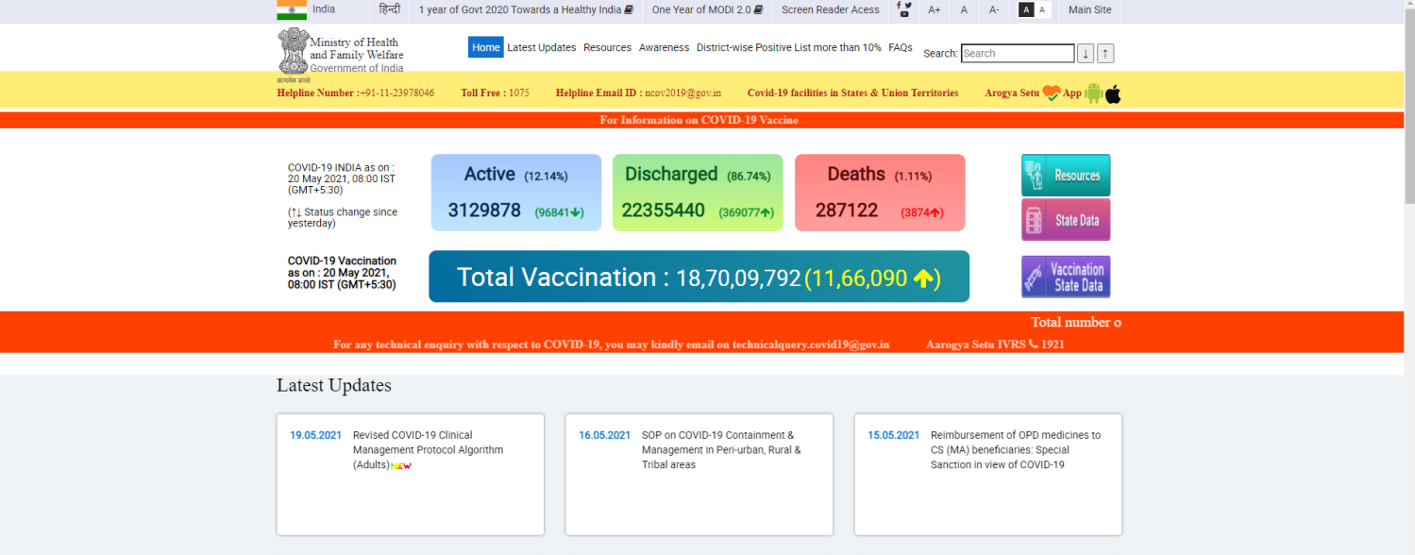

Thanks to [COVID19India.org] (<https://github.com/covid19india/api>) for open-source API.

Thanks to <https://www.covid19india.org/> for Real Time Data collection

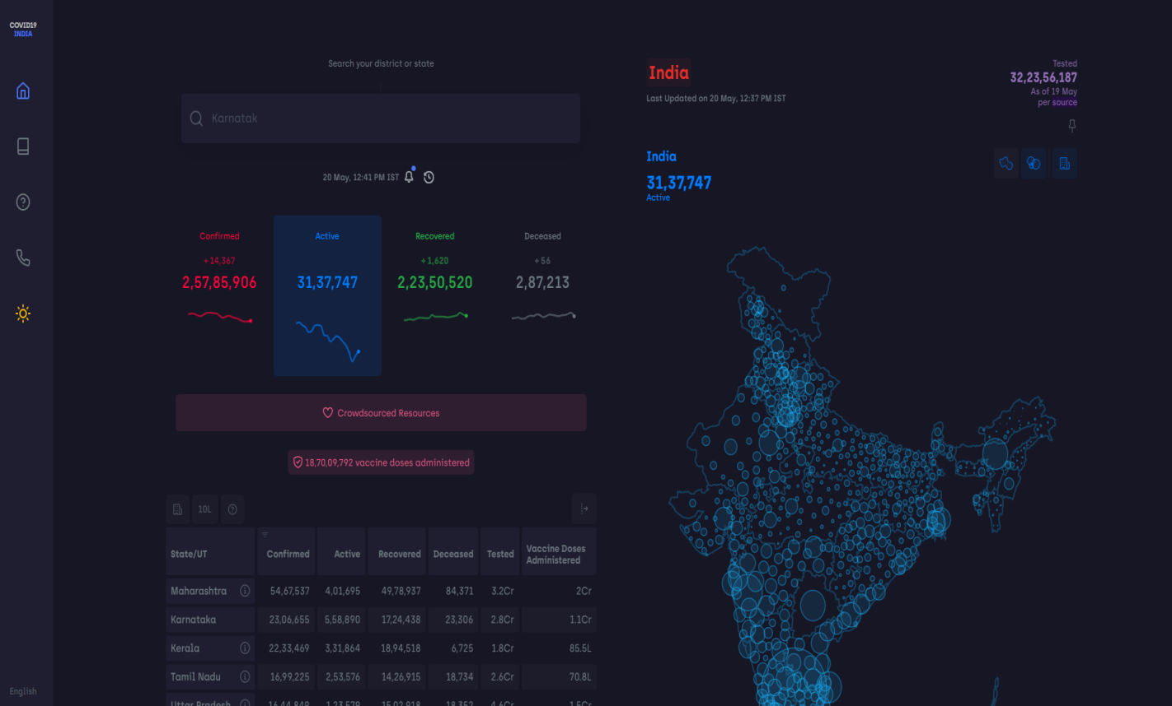

**New Features**

* Offline caching using Room persistance library (injected with Dagger2)
* Ability to pin specific countries (also using Room)
* Statewise data of Indian States (with sorting options)

**Requirements:**

* Any Operating System (i.e Linux, Windows)
* Android Studio
  1. **Process and Function of Covid-19 Tracker Application**

**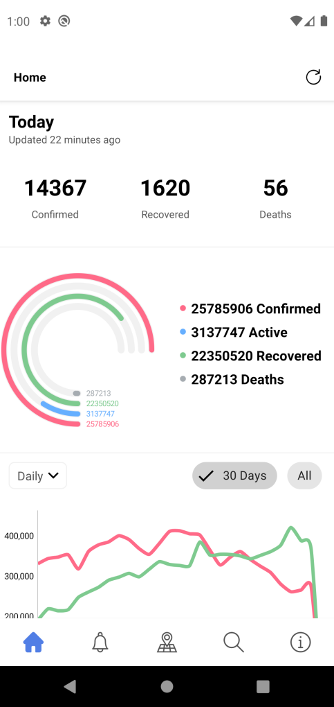5.7.1 Home Screen:** The home screen Displays data in Real-time fetched from an open source API of <https://www.covid19india.org/>

* (<https://github.com/covid19india/api>). In the screenshot above we can visualize Total no. of Confirmed cases, Deaths and recovered in the last 22 minutes(Since we last refreshed our app). The Pie diagram below displays Total no cases throughout the pandemic
* Given below is a graph representation of the above stated pie chart displaying the same data but in graph format.We can switch from no.of days to all by simply clicking the (ALL )UI component

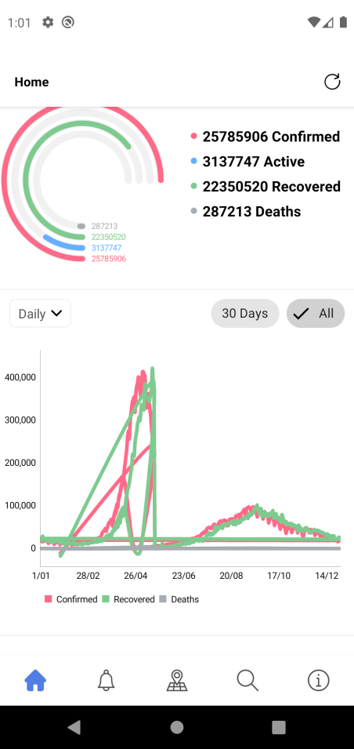

* 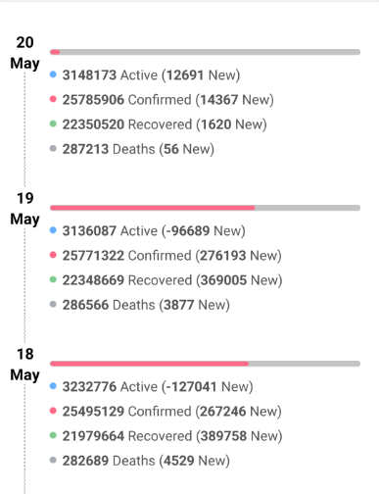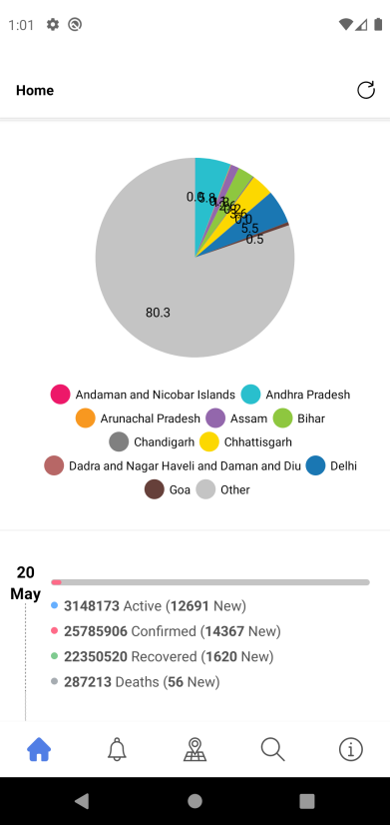The pie diagram below displays data from all over India with a percentage-pie diagram.Every state is indicated with a different color for identification purpose.The status bar below the Donut Diagram Displays daily data of selected state(Which refreshes daily).

**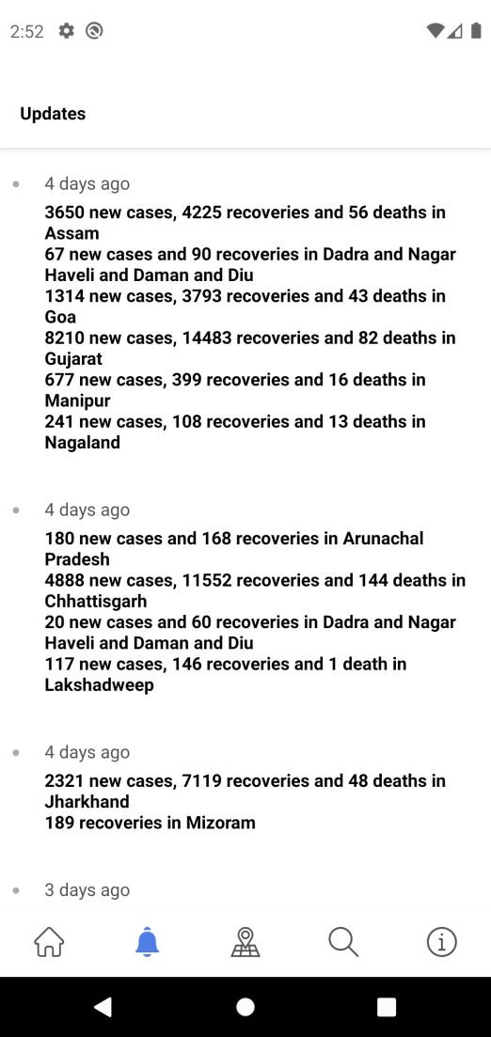**

**5.7.2 Update Section:** The update section (above) in this App contains recent news and recovery rates from all over India.Just a small filler section displaying news and info in different state

**5.7.3** **Covid-19 Real-Time Data Page**

The Covid-19 Real-Time Data Page contains data from all over the world and states within it.

Further classifying them into different states and city

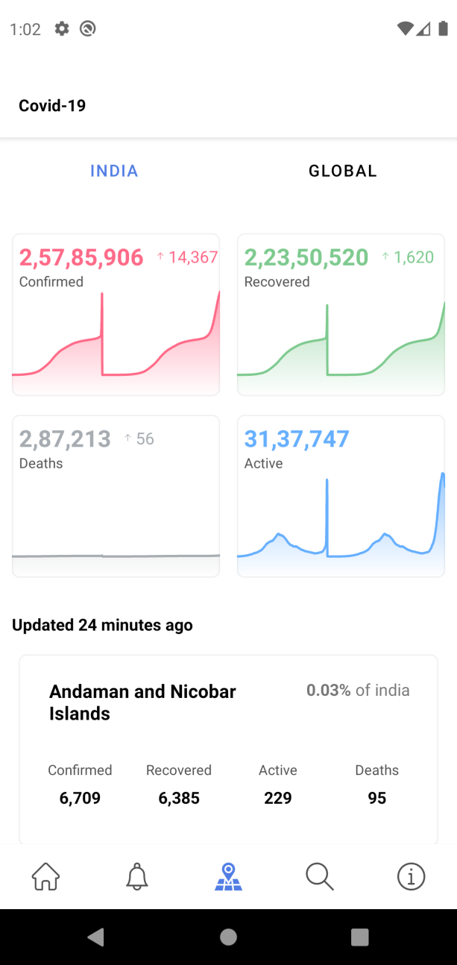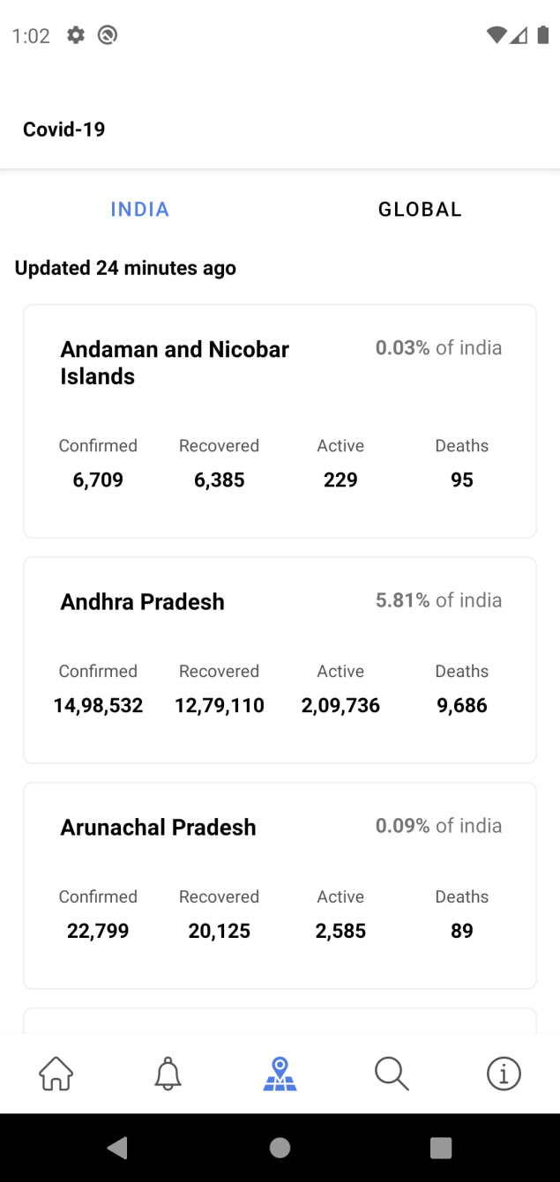

The above data states all active cases in different regions of the world.Global data displays all over the world. Below data displays covid cases inside Andhra Pradesh

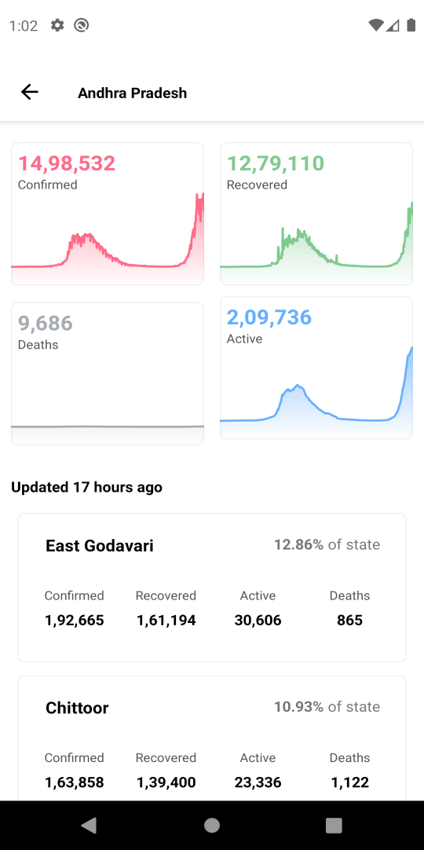

* Data above displays sub stats of Andhra Pradesh
* 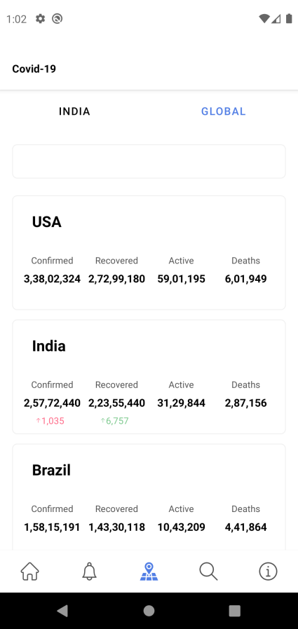Below data Displays the Global data of Covid-19

**5.7.4 Search section:**

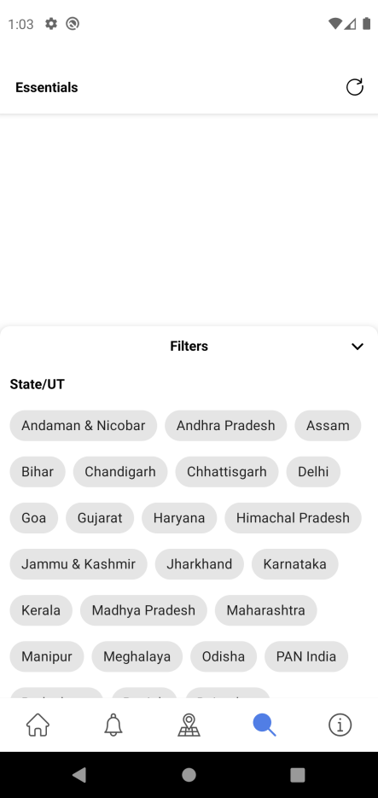

The search section in this app contains helpline numbers and data from all states of India. User can select any state to view helpline info and aid from.

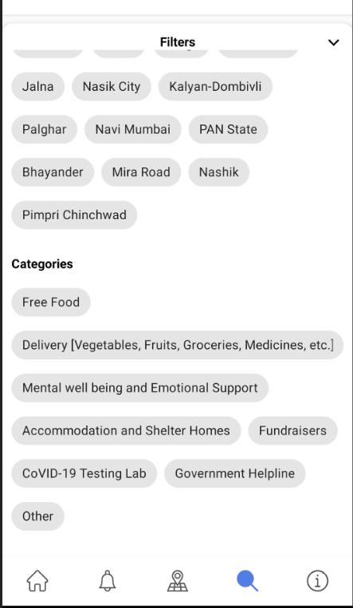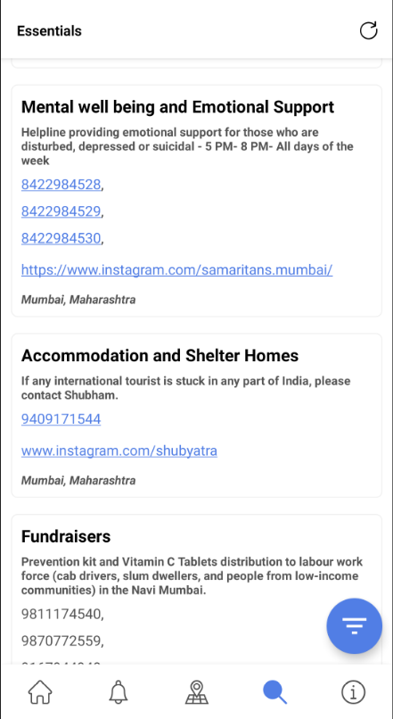

**5.7.5 About me page**

About me page contains devloper info and helpful links

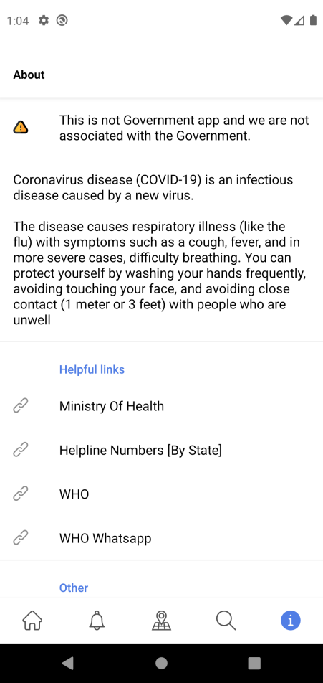

**5.8 Database inspector (Android studio)**

**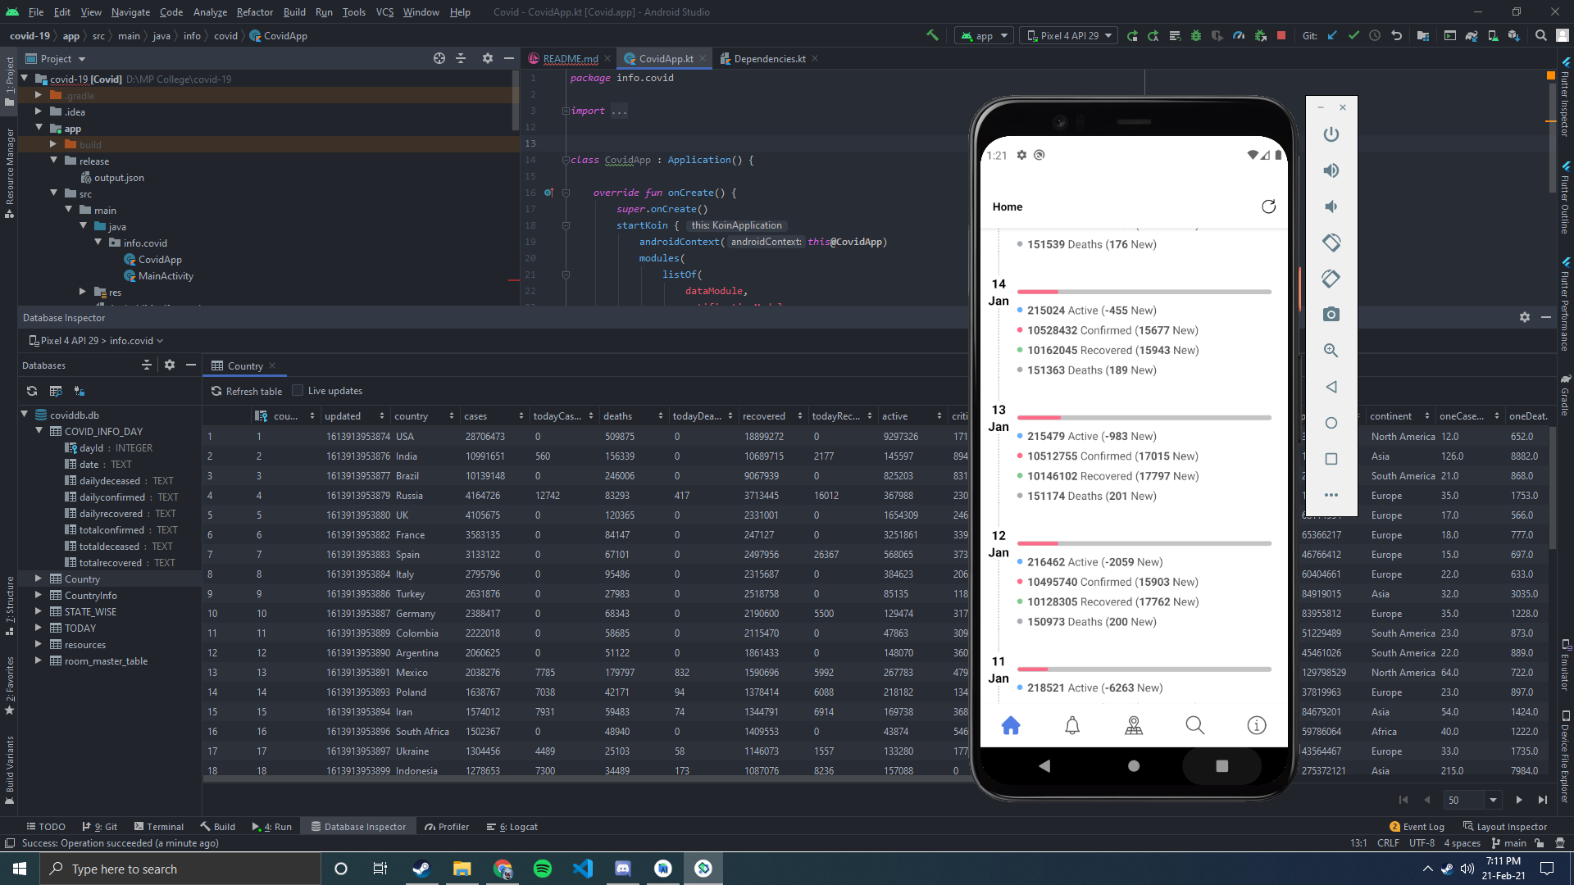**

**5.9 Frequently Asked Quesitons (FAQs):**

* When I download the App
* What is stored by Apple store or Google play?
* The fact that you’ve downloaded the App and which Device you downloaded it to.

* When I Register
* What is stored in our database?
* Your App user ID
* The model of your device
* When I have app running
* What is monitored by my phone?
* Power and data usage of app will be monitored by your phone
* If I delete App
* What is still stored in our database
* Your App user Id
* The make and model of your phone

**5.10 Test Cases:**

|  |  |  |  |  |  |  |  |
| --- | --- | --- | --- | --- | --- | --- | --- |
| SR NO | Test Case ID | Test Case Objective | Prerequisites | Input | Expected Output | Actual Output | Status |
| 1 | TC\_1 | To test the ‘Home’ start button | Home start button should be present and active | Click | Displays ‘Home’ | Click | Pass |
| 2 | TC\_2 | To test the ‘All’ button module | ‘All’ button should be present and active | Click | Switches data from current to ‘All’ | Switches data from current to ‘All’ | Pass |
| 3 | TC\_3 | To test ‘30 Days’ button | ‘30 Days’ button should be present and active | Click | Switches data from current to ‘30 Days’ | Switches data from current to ‘30 Days’ | Pass |
| 4 | TC\_4 | To test the ‘Alert’ button | ‘Alert’ button should be present and active | Click | Displays the updates | Displays the updates | Pass |
| 5 | TC\_5 | To test the ‘Refresh’ button | ‘Refresh’ button should be present and active | Click | Displays real-time data when clicked | Displays real-time data when clicked | Pass |
| 6 | TC\_6 | To test the ‘Core’ button | ‘Core’ button should be present and active | Click | Displays the complete database | Displays the complete database | Pass |
| 7 | TC\_7 | To test the ‘Global’ button | ‘Global’ button should be present and active | Click | ‘Global’ button should display global database | ‘Global’ button should display global database | Pass |
| 8 | TC\_8 | To test the ‘India button | ‘India’ button should be present and active | Click | ‘India’ button should display global database | ‘India’ button should display global database | Pass |
| 9 | TC\_9 | To test the ‘Dashboard’ module | ‘Dashboard’ module should be present and active | Click | Displays inner state database of given module | Displays inner state database of given module | Pass |
| 10 | TC\_10 | To test the ‘Essentials’ button | ‘Essentials’ button should be present and active | Click | Displays ‘Essentials’ database | Displays ‘Essentials’ database | Pass |
| 11 | TC\_11 | To test the ‘About me’ button | ‘About me’ button should be present and active | Click | Displays the developer info | Displays the developer info | Pass |

|  |  |
| --- | --- |
| ID | 1 |
| Project | COVID-19 Real-Time Android App |
| Product | COVID-19 Real-Time Android App |
| Release Version | 1.0.0 |
| Module | ‘About me’ module |
| Detected Build Version | 1.6.1 |
| Summary | The main defect is in the ‘About me’ module |
| Description | Had difficulty in displaying ‘Github’ Drawable |
| Steps to replicate | We had to check github.xml file |
| Actual Result | It won’t display the github drawable res icon |
| Expected Result | Displaying the github drawable res icon |
| Detect Severity | Medium |
| Defect Priority | High |
| Reported By | Sarvesh |
| Assigned to | Aditya |
| Status | Completed |
| Fixed Build Version | 1.6.2 |

**5.11 Defect Report:**

|  |  |
| --- | --- |
| ID | 2 |
| Project | COVID-19 Real-Time Android App |
| Product | COVID-19 Real-Time Android App |
| Release Version | 1.0.0 |
| Module | ‘About me’ module |
| Detected Build Version | 1.6.1 |
| Summary | The main defect is in the ‘About me’ module |
| Description | Had difficulty in displaying ‘Twitter’ drawable |
| Steps to replicate | We had to check twitter.xml file |
| Actual Result | It won’t display the twitter drawable res icon |
| Expected Result | Displaying the twitter drawable res icon |
| Detect Severity | Medium |
| Defect Priority | High |
| Reported By | Meet |
| Assigned to | Aditya |
| Status | Completed |
| Fixed Build Version | 1.6.2 |

**CHAPTER 6**

**RESULTS AND APPLICATION**

**Chapter 6 : Results and Application**

Each publication from the final set of 61 primary studies was read in full after they passed the quality assessment and relevant context data, qualitative and qualitative data was extracted. All primary studies are centred on the research questions and a theme in relation to the challenges, recommendations and future directions of contact tracing apps and related technology in the fight against COVID-19 and future pandemic outbreaks. Figure below shows the percentages of different themes of the 61 primary studies, after the quality assessment selection and were included in the analysis and discussion of results. Most research outputs considered in this SLR are published in academic journals. Also, there were few outputs published as preprints, government, and technical reports.

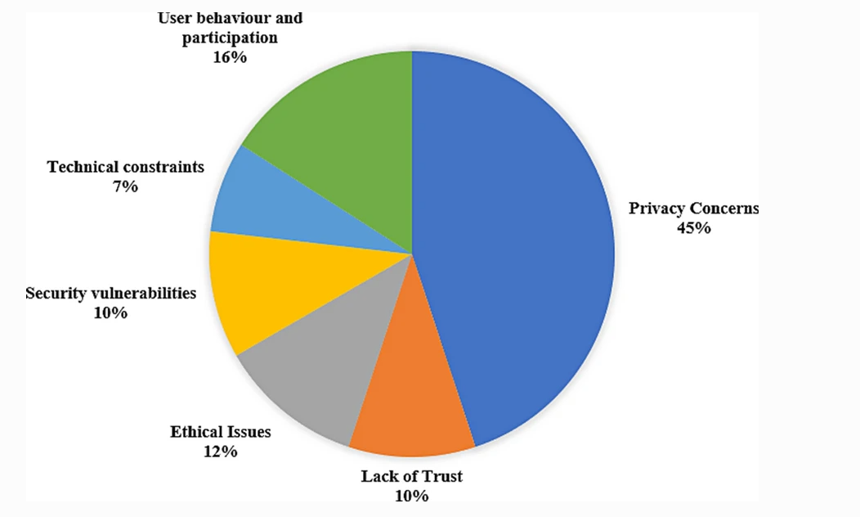

The themes identified in the primary studies show that almost half (45%) of all studies on contact tracing apps for the COVID-19 pandemic are concerned with user privacy. User behaviour and participation is the second most popular theme amongst the primary studies, with a percentage of 16%. This is followed by ethical issues surrounding the use of contact tracing apps in 12% of the primary studies. Lack of trust in the government especially for neo-liberal societies accounts for 10% of the primary studies. The studies focused on the plausibility of contact tracing apps being used for government surveillance as one of the reasons behind the unwillingness of the population to use them. Security vulnerabilities are the jointly third commonest theme, with a proportion of 10%. The last common theme of the primary studies is technical constraints that affect the adoption of contact tracing apps, which accounts for 7%.

**6.1 Discussion of results:**

The decision to develop and deploy contact tracing apps for tracking and tracing the spread of the COVID-19 pandemic continues to raise data privacy concerns and a balance between user data privacy and societal benefit has been considered [[48](https://link.springer.com/article/10.1007/s13755-021-00147-7#ref-CR48)]. This coupled with its effectiveness, ethical considerations, security risks, and technical issues has been highlighted as major challenges affecting mass acceptance amongst the population in neo-liberal societies. In this section, we present findings from the selected primary studies that highlight the major challenges affecting contact tracing apps in the fight against COVID-19, recommendations to address these challenges and future directions in the use of digital contact tracing technology to fight future pandemics.

**Q1: What are the current challenges of contact tracing apps in societies?**

It is important to state that this systematic literature review focuses on the challenges of contact tracing apps that influence their wide acceptance and adoption, especially in societies. However, it is imperative to also note that some of the discussion in our findings could apply to other demographics and digital applications.

User data privacy concerns— highlights that justification for privacy infringements of users is hypothetically justifiable in cases where contact tracing apps have the potential to contribute to the saving of many lives and reduce enormous suffering caused by a blanket population lockdown. Hence, people should be prepared to trade-off privacy encroaching contact tracing apps for civil liberty and see it as a public duty to save lives as lockdown is being eased. However, an app encroaching on people’s privacy while providing little contribution, compared to other measures in tackling the spread of COVID-19 would be ethically dubious, especially in neo-liberal societies. Privacy concerns related to user data has been of one the significant issue affecting the acceptance and willingness to use contact tracing apps as shown in primary studies Questions such as how user data will be anonymized, where the data will be stored, who has access to the data, how it will be shared, used and destroyed when the pandemic is over have been subjects of huge debate. These are the main reasons that influence unwillingness to use these contact tracing apps.

**Lack of Trust—**The lack of trust in government and their motive appears to be a key factor that creates a negative effect on people’s decisions to install a contact tracing app on their phones especially in societies where the use is not mandatory and success depends on the establishment of sustained and sound public trust and confidence as shown in primary studies . Especially in the USA in the post 9–11 era, lack of the public’s trust in governments has been impacted since Edward Snowden’s revelations on US government global surveillance program.

Apart from surveillance concerns associated with central authorities’ access to user data, concerns associated with access to user data by third parties have also been raised. These include any individual with whom a user has exchanged tokens in the contact tracing app based on some notion of physical proximity, big data analysis companies, or malicious actors where the contact tracing app’s system is naive or vulnerable to information leakage . In May 2020, the official COVID-19 contact tracing app for the state of North Dakota, USA, was found to send user location data and the unique user identifier to Foursquare and other data to Google including a bug-tracking company with the users’ consent

A scientific Data Protection Impact Assessment (DPIA) of contact tracing app designs (including centralized and decentralized models) conducted in the primary study found that none of the proposed designs ensures proper anonymization, and that informed consent would not be a legitimate legal ground for the processing, that data subjects’ rights are not sufficiently safeguarded and that no design provides for sufficient purpose-binding. Similar findings in the application of the European Data Protection Board (EDPB) guidelines in the assessment of three contact tracing apps (Stopp Corona, NHS COVID-19 and TraceTogether), showed varying compliance with the guidelines criteria . The issues highlighted show that maintaining the balance between trust in government institutions and public health is a huge challenge in the adoption of contact tracing apps in the fight against COVID-19.

**Ethical issues**—In many countries, residents have been living under lockdown with their civil liberties heavily curtailed. Many businesses have been forced to stop operations forcing millions out of work. According to the International Monetary Fund’s (IMF) April World Economic Outlook, the global growth in 2020 is expected to fall to -3% making it the worst recession since the Great Depression . The United Kingdom’s economic GDP is projected to fall by 11.5% while the USA, China, Germany, and France GDPs are predicted to fall by 6.6%, 2.6%, 6.6%, and 11.4% respectively. As countries slowly lift restrictions and business open to enable quick economic recovery, digital contact tracing itself can contribute to general fairness risk associated with discriminate mitigation measures . For example, disadvantaged workers are less likely to be able to work from home, engaging in work means that they are at higher risks of becoming infected and are more likely to form social ties with others in similarly precarious arrangements. Therefore, they may be forced to quarantine simply because they have been in close proximity with others in the same social group although they may not be at high risk of infection. The lack of smartphones and internet access, as well as the share of informal employment all come together to disproportionately impact the low-income communities which continue to drive the health divide rooted in social status and economic differences even further

Primary studies , discuss the risk of data collected through contact tracing apps by public health authorities and governments can be used not just for epidemiological studies and surveillance but also for behavioural profiling of a population. The behavioural profiles if correlated with other demographic and socio-economic data may motivate selective policies in which a population that has been measured as being on average more willing to take risks are treated differently by future restrictions than other groups whose compliance is supposedly higher. This raises serious ethical issues as data can be used to discriminate against a population or geographic locations where cases of COVID-19 are higher. For example, behavioural scoring can be used to determine access to medical resources, funding, treatment, etc. It was discovered that Bahrain’s ‘BeAware Bahrain’ app has been sharing data with a national television show called Are You at Home? which offered prizes to those who stayed at home during Ramadan . In South Korea, contact-tracing laws permit the government to determine the immigration status of infected individuals. Sinha and Paterson highlight that if such laws exist in the U.S., undocumented communities may not seek healthcare and that over time the same technologies and laws could be used to track undocumented migrants.

**Security vulnerabilities-**Security flaws in the design and implementation of contact tracing apps have the potential to put sensitive personal details of users at risk. A recent investigation by Amnesty Security Lab discovered a significant weakness in the configuration of Qatar’s mandatory EHTERAZ contact tracing app . The vulnerability could allow hackers access to highly sensitive personal information, including the name, national ID, health status, and location data of more than one million users. Similar vulnerabilities have been disclosed in India’s Aarogya Setu and Pakistan’s Covid-19 Gov PK apps. These vulnerabilities were from apps that have been tested by security researchers so far. Other proposed contact tracing apps may have similar or different security flaws that make them susceptible to attacks and data leaks.

The primary study described possible attacks on Bluetooth technology used by contact tracing apps. Recent Bluetooth vulnerabilities include BlueFrag (CVE-2020-0022 which affected Android devices running Android 8.0 to 9.0) and Bluetooth BIAS Attack (affected multiple Android and iOS devices) were disclosed in February and May 2020 respectively and required patching. However, many Android devices did not receive this update as more than one billion Android devices around the world are no longer supported by security updates, leaving them potentially vulnerable to attacks. According to Google’s data from 2019, around 40% of Android active users worldwide are on version 6.0 or earlier and no longer receive security updates . A successful Bluetooth BIAS attack would allow a malicious actor to impersonate a device from a previous secure Bluetooth connection pairing between two devices. This can be leveraged to conduct social engineering attacks or take control of the vulnerable device as contact tracing apps always require Bluetooth to be enabled to function. Other possible attacks and vulnerabilities susceptible to contact tracing apps are described in primary studies.

**Technical constraints—**The development and roll-out of contact tracing apps revolve around several assumptions that raise questions about its efficacy to advance public health in the fight against COVID-19. These assumptions are that a large percentage of the population have access to compatible smartphones and an internet connection, the application’s design, that Bluetooth signals are accurate, and that people will choose to install and use the apps .

According to Statistic, the current number of smartphone users in the world today is 3.5 billion, and this means 44.98% of the world’s population owns a smartphone . From this percentage, smartphones running the Android operating system held an 87% share of the global market in 2019 compared to the mobile operating system developed by Apple (iOS), which had a 13% share of the market [[84](https://link.springer.com/article/10.1007/s13755-021-00147-7#ref-CR84)], thus making Android the most popular mobile operating system used across the world. However, more than one billion Android devices are 2 years or more out of date and do not receive updates from device manufacturers and carriers. This means many Android devices may not benefit from updates to the new COVID-19 contact tracing system Google has built in collaboration with Apple. For example, the Trace Together app requires Android 5.1 or higher, while the CovidSafe app works on Android 6.0 or higher. On iOS devices, both Trace Together and CovidSafe require iOS version 10 or higher . Currently, most back-end systems and contact tracing apps are poorly inter-connected since they are developed by different government agencies, health authorities, and organizations .

Access to mobile internet across the world is not evenly distributed. According to the latest report from the GSMA Mobile Economy, smartphone subscriber penetration is considerably low in Sub-Saharan Africa (45%) compared to other regions like Europe (86%), North America (83%), Greater China (82%) and Asia Pacific (60%). This disparity is closely related to the GDP per capita of countries where citizens from poorer countries are less likely to own a smartphone. Even in regions like Europe, not all households have access to mobile internet and smartphones. In the UK, figures released by the Office for National Statistics (ONS), show that a third of households still do not have access to mobile broadband . The latest figures in 2020 show that 30% of UK senior citizens aged 55 years and above do not own or have access to a smartphone and an estimated 21% of young adults aged 18 years and above do not have a smartphone . This digital divide and inequality mean that health care development in the form of contact tracing apps and related technologies rapidly does not become available to many people within the population and has the unintended but inevitable consequence of fueling health inequality.

Bluetooth signals suffer from accuracy problems and will require developers to fine-tune how signals will be transmitted by lowering the transmission power to prevent such long-distance reception. Primary study highlighted different Bluetooth versions and smartphone chipset implementations that can result in different operational and information security aspects of its use for contact tracing. Signal strength can vary significantly depending on the relative orientation of smartphones, on absorption by the human body, reflection, or absorption of radio signals in buildings and on trains. According to the inventors of Bluetooth, Jaap Haartsen, and Sven Mattisson, the signal’s path loss will vary significantly depending on extenuating conditions (free space or obscured) . Duration, proximity, and direction of signal strength between two devices would also need to be measured to deal with problems associated with false positives. Especially in scenarios where the contact tracing app detects a non-valid exposure or false negative, where the app fails to detect a valid exposure because the distance was miscalculated, or even because of other external factors and extenuating circumstances. The inevitable danger of non-valid exposure measurements is linked to the risk that users are wrongly isolated, potentially several times in succession, with considerable economic and social consequences to those affected . The SARS-CoV-2 virus could spread by touching an object or surface with a virus present from an infected person, and then touching the mouth, nose, or eyes. Hence in such cases, a contact tracing app will not be able to detect this and may give people a false sense of security.

**User behaviour and participation**—Most citizens over the age of 65 are not tech-savvy compared to the younger generation. Using the latest data on smartphone usage by age, sourced from the UK’s communications regulator OFCOM, there is a digital divide between adults of certain age groups and their attitudes towards the use of smartphones with young adults more likely to use contact tracing apps compared to senior citizens in the UK . This intergenerational divide is supported by the study of participants in Singapore demonstrated in a primary study . The success of any voluntarily installed app, for whatever purpose, is dependent upon user buy-in. There are several dimensions to that judgment of acceptability of technology, including its benefits and disbenefits, the moral or social imperatives, the perceived efficacy of the app, and the behaviour of significant others in the lives of the potential user. Psychological research into the adoption of technologies focuses on these issues, where wetware meets hardware and software.

Primary studies , highlights adoption is determined by individual risks, cultural difference and social preferences, not by the wider health benefits to society. However, primary study , highlighted that a perceived realistic threat to life or health during the pandemic is a more important predictor of acceptance of contact tracing technologies in Poland. The study also found women were more willing to accept their use than men. Primary study concluded that it is difficult for policymakers to design one app that fits all individuals in a society. Especially when the propensity to accept such non-mandatory apps varies between critics, advocates, and undecided individuals amongst the neo-liberal population. Tracking or screening technologies can work when the public understands the value of them for their health and wellbeing, and both parties are signed up for that greater purpose . Under such conditions, surveillance concerns are minimized. This is confirmed by primary study in a qualitative, focus-group study of participants in the U.K. Primary study report a study of intentions to use a contact-tracing app in Australia, with the conclusion that uptake of the software can be increased if the security concerns are addressed, but that message framing did not make a significant difference to intention when autonomy-controlling and supportive messages were compared. Supportive messages involve choice and freedom, whereas autonomy-controlling messages use model verbs such as “should” and “must”.

Discussion from the primary studies shows an overwhelming consensus that privacy concerns is the most significant reason for the lack of acceptance and use of contact tracing apps amongst the population in societies. This issue is largely influenced by the cultural differences in these societies, lack of evidence of wider health benefits of these apps and growing concerns that government agencies could use data collected for digital mass surveillance.

**Q2: What recommendations can be implemented to address these challenges and improve mass acceptance?**

Based on the current challenges of contact tracing apps in the fight against COVID-19 in societies identified in Q1, we discuss recommendations that can be applied to remedy these issues and can influence its wide adoption and acceptance:

Addressing user data privacy concerns—Maintaining a balance especially between user privacy and societal benefit is a huge challenge if digital contact tracing using mobile apps is to succeed in the fight against COVID-19. Also, influencing user behaviour in the participation, and dealing with technical constraints associated with the underlying technology is essential if contact tracing apps are to succeed now and in respect of dealing with future pandemics. In this section, we discuss recommendations in addressing some of these issues and future considerations in the development and implementation of digital contact tracing. Data collected from such apps should only be used to support public health measures, the source code should be made public and subjected to public analysis and finally, its use must be voluntary, used with the explicit consent of the user and the systems must be designed to be able to be switched off, and all data deleted when the current pandemic is over. There are suggestions that a non-partisan independent committee with representatives from legal, health, and privacy experts should be established to oversee the development of contact tracing apps, its information ecosystem, and data governance. Only anonymized aggregated data should be shared with public health authorities and any personal identifiable information must be deleted once the pandemic is over .

Addressing security vulnerabilities—On issues associated with Bluetooth, it is recommended that the Bluetooth Low Energy (BLE) signal should be regulated in a standardized manner when operating a contact tracing app so that the effective range of the protocol is reduced . Legislation should be put in place which mandates smartphone manufacturers and carriers to provide critical system updates especially for Android devices vulnerable to critical Bluetooth vulnerabilities such as Blue Frag and BIAS attack. Mitigation to address security vulnerabilities promptly, application code review and secure software development must be considered to minimize risk to user data .

Addressing technical constraints—Proximity accuracy issues with Bluetooth technology has been addressed in the recent update of Bluetooth Low Energy (BLE). However, there is still room for improvement in the development of new protocols and refined calibration of BLE signal strength that can enhance this technology .

Improving user behaviour and participation—Currently, there a few studies about the psychological factors that would influence the adoption of an app for contact tracing at present for the ongoing outbreak of COVID-19. Findings from the primary studies, suggests that people would respond best to messages which alleviate their security concerns, emphasize personal autonomy, and where the societal benefits are clearly articulated. It is also important that policy makers study their demographic to understand user perception. Designing a contact tracing app that targets most of the population and addresses their concerns (privacy and usability) can increase mass acceptance. Moreover, to realize their intended societal benefits, contact tracing apps require mass acceptance.

Our findings reveal that most of the primary studies consider showcasing the societal benefits of contact tracing apps, addressing privacy concerns, technical constraints and security issues that can influence the mass acceptance and use of contact tracing apps in societies.

**Q3: What are the future directions and considerations in the use of digital contact tracing technologies in the fight against future pandemic outbreaks?**

Since there are several underlying challenges of digital contact tracing apps in the light of their relevance in the fight against the COVID-19 pandemic, many of the issues are inherited from mobile applications as well. Our study shows that user privacy concerns are the most pressing challenge identified by most of the studies in their analysis of the implications of contact tracing apps, especially for societies. One of the positives of these apps is their ability to track and trace the spread of the infection in real-time whilst complementing other manual contact tracing methods. Despite these, for contact tracing apps to be effective, a large number of the population would need to install and use these apps. Based on the outcome of this SLR and our findings, we present the following future considerations and directions for contact tracing apps and related technologies in the fight against COVID-19 and future pandemic outbreaks that are worth investigating and implementing to encourage willingness and mass adoption by the wider population:

Adopting less-invasive and privacy-preserving technologies—For future considerations, the use of less-invasive technologies such as Artificial Intelligence (AI) and Machine Learning (ML) has been proposed to help analyse the level of infection by the SARS-CoV-2 virus by identifying hotspots, tracing, and monitoring infected persons as described in primary studies. Other methods described in the primary study [, propose the use of thermal-based imaging using the Internet of Medical Things (IoMT) and other Internet of Things (IoT) devices to trace and track positive cases and help control the spread of COVID-19 infection and future infectious disease outbreaks. The use of a privacy-preserving contact tracing scheme in blockchain-based medical applications has also been proposed .

Transparency—To encourage the willingness to adopt and use contact tracing apps, policymakers, developers, governments, and public health authorities in societies must adopt a feedback mechanism during the phases of deployment to create public confidence, trust and participation. Citizens deserve clarity on the purpose of data collection, types of data collected, who has access to such data, the modalities, extent and timeline for data deletion .

Influencing human behaviour—It is important to study human behaviour when designing and developing contact tracing apps and related digital technologies before deploying and integrating them amongst the population. This includes studying a significant amount of theories and models such as the technology acceptance model, innovation diffusion theory, the theory of reasoned action, health belief models and theory of planned behaviour, social cognitive theory, and motivation theory can be used to explore the acceptance and use of future contact tracing technologies .

Ethical considerations—For government, technology developers, decision-makers and public health authorities, there is the need to translate the ethical–legal considerations into actionable safeguards that can unlock the promise of contact tracing apps and related digital technologies while avoiding harm and managing risks in the fight against future pandemics .

Based on the results of this survey and our observations, digital technologies can be used to support manual contact tracing and tracking methods in the fight against COVID-19 and future pandemic outbreaks. However, neo-liberal governments and public health authorities should consider the use of alternative technologies that do not invade user privacy. They also need to be transparent with the public on how any data collected will be used. Strategies and incentives to influence user participation should also be considered well in advance to encourage mass acceptance amongst the wider population.

**CHAPTER 7**

**CONCLUSION AND**

**FUTURE WORK**

**Chapter 7 : Conclusion and Future Work**

The impact of the COVID-19 pandemic represents an unprecedented challenge to public health authorities and respective governments across the world. This has brought severe pressure on health services and introduced radical changes to the way of life for both individuals and organizations. In a way to stop the infection of the SARS-CoV-2 virus from spreading, public health authorities have considered and introduced robust contact tracing systems which include the use of digital contact tracing apps. In this paper, we discussed the mandatory application of contact tracing apps in East Asia in containing the spread of the SARS-CoV-2 virus and the challenges faced by neo-liberal societies in their use to fight against the COVID-19 pandemic. Although contact tracing apps are a promising technology for rapid tracing and tracking of infected persons, they can support manual contact tracing and tracking methods in the control of the SARS-CoV-2 virus. However, many people have an intrinsic mistrust of the government especially in societies and are concerned that the use of contact tracing apps could be the beginning of more pervasive government surveillance. Also, since these apps are not mandatory, it is difficult to predict mass acceptance and participation. If contact tracing apps are to succeed, it is important governments and policymakers gain the trust of their citizens and show adequate transparency in how user data is collected and used. Its efficacy and how these challenges are currently addressed in the fight against this novel disease will determine the role of digital contact tracing technologies in future pandemic outbreaks and what lessons can be learned from identified inadequacies.

Future potential research agenda concerning the impact and effectiveness of contact tracing apps and related technologies in societies needs to the considered. Studies that evaluate the effectiveness of the recommendations implemented by various policymakers, governments, and public health authorities to verify whether they influence the willingness and mass acceptance of this technology also needs to be carried out.

**Chapter 8 : References & Bibliography**

* Centers for Disease Control and Prevention. About variants of the virus that causes COVID-19. (2021). <https://www.cdc.gov/coronavirus/2019-ncov/transmission/variant.html>. Accessed 19 Feb 2021.
* PEPP-PT, Pan-European Privacy-Preserving Proximity Tracing, PEPP-PT. (2020). <https://www.pepp-pt.org/content>. Accessed 24 Apr 2020.
* Kwok KO, Tang A, Wei VWI, Park WH, Yeoh EK, Riley S. Epidemic models of contact tracing: systematic review of transmission studies of severe acute respiratory syndrome and middle east respiratory syndrome. Comput Struct Biotechnol J. 2019. <https://doi.org/10.1016/j.csbj.2019.01.003>.
* Riley S, Fraser C, Donnelly CA, Ghani AC, Abu-Raddad LJ, Hedley AJ, Leung GM, Ho LM, Lam TH, Thach TQ, Chau P, Chan KP, Lo SV, Leung PY, Tsang T, Ho W, Lee KH, Lau EMC, Ferguson NM, Anderson RM. Transmission dynamics of the etiological agent of SARS in Hong Kong: impact of public health interventions. Science. 2003. <https://doi.org/10.1126/science.1086478>.
* Saurabh S, Prateek S. Role of contact tracing in containing the 2014 Ebola outbreak: a review. Afr Health Sci. 2017. <https://doi.org/10.4314/ahs.v17i1.28>.
* Kucharski AJ, Russell TW, Diamond C, Liu Y, Edmunds J, Funk S, Eggo RM, Sun F, Jit M, Munday JD, Davies N, Gimma A, van Zandvoort K, Gibbs H, Hellewell J, Jarvis CI, Clifford S, Quilty BJ, Bosse NI, Abbott S, Klepac P, Flasche S. Early dynamics of transmission and control of COVID-19: a mathematical modelling study. Lancet Infect Dis. 2020. <https://doi.org/10.1016/S1473-3099(20)30144-4>.
* He X, Lau EHY, Wu P, Deng X, Wang J, Hao X, Lau YC, Wong JY, Guan Y, Tan X, Mo X, Chen Y, Liao B, Chen W, Hu F, Zhang Q, Zhong M, Wu Y, Zhao L, Zhang F, Cowling BJ, Li F, Leung GM. Temporal dynamics in viral shedding and transmissibility of COVID-19. Nat Med. 2020;26:672–5. <https://doi.org/10.1038/s41591-020-0869-5>.
* Petrosillo N, Viceconte G, Ergonul O, Ippolito G, Petersen E. COVID-19, SARS and MERS: are they closely related? Clin Microbiol Infect. 2020. <https://doi.org/10.1016/j.cmi.2020.03.026>.
* Wu JT, Leung K, Leung GM. Nowcasting and forecasting the potential domestic and international spread of the 2019-nCoV outbreak originating in Wuhan, China: a modelling study. Lancet. 2020. <https://doi.org/10.1016/S0140-6736(20)30260-9>
* Liu T, Hu J, Kang M, Lin L, Zhong H, Xiao J, He G, Song T, Huang Q, Rong Z, Deng A, Zeng W, Tan X, Zeng S, Zhu Z, Li J, Wan D, Lu J, Deng H, He J, Ma W. Transmission dynamics of 2019 Novel Coronavirus (2019-nCoV). SSRN Electron J. 2020. <https://doi.org/10.2139/ssrn.3526307>.
* Chen H, Yang B, Pei H, Liu J. Next generation technology for epidemic prevention and control: data-driven contact tracking. IEEE Access. 2019;7:2633–42. <https://doi.org/10.1109/ACCESS.2018.2882915>.
* Ferretti L, Wymant C, Kendall M, Zhao L, Nurtay A, Bonsall DG, Fraser C. Quantifying dynamics of SARS-CoV-2 transmission suggests that epidemic control and avoidance is feasible through instantaneous digital contact tracing. MedRxiv. 2020. <https://doi.org/10.1101/2020.03.08.20032946>.
* Müller J, Kretzschmar M. Contact tracing—old models and new challenges. Infect Dis Model. 2021;6:222–31. <https://doi.org/10.1016/j.idm.2020.12.005>.
* Vaughan A. The problems with contact-tracing apps. New Sci. 2020. <https://doi.org/10.1016/s0262-4079(20)30787-9>.
* Sinha P, Paterson AE. Contact tracing: can ‘Big tech’ come to the rescue, and if so, at what cost? EClinicalMedicine. 2020. <https://doi.org/10.1016/j.eclinm.2020.100412>.
* Hearn A. Digital contact tracing will fail unless privacy is respected, experts warn, Guard. Newsp. (2020). <https://www.theguardian.com/world/2020/apr/20/coronavirus-digital-contact-tracing-will-fail-unless-privacy-is-respected-experts-warn>. Accessed 11 June 2020.
* Fussel S, Knight W. The apple-google contact tracing plan won’t stop Covid alone, Wired.Com. (2020). Accessed 24 Apr 2020.
* Parker MJ, Fraser C, Abeler-Dörner L, Bonsall D. Ethics of instantaneous contact tracing using mobile phone apps in the control of the COVID-19 pandemic. J Med Ethics. 2020;46:427–31. <https://doi.org/10.1136/medethics-2020-106314>.
* Altmann S, Milsom L, Zillessen H, Blasone R, Gerdon F, Bach R, Kreuter F, Nosenzo D, Toussaert S, Abeler J. Acceptability of app-based contact tracing for COVID-19: cross-country survey evidence. MedRxiv. 2020. <https://doi.org/10.1101/2020.05.05.20091587>.
* <https://www.who.int/health-topics/coronavirus#tab=tab_1>
* <https://www.webmd.com/lung/coronavirus>
* Findlay S, Palma S. Coronavirus contact-tracing apps struggle to make an impact, Financ. Times. (2020). <https://www.ft.com/content/21e438a6-32f2-43b9-b843-61b819a427aa>. Accessed 11 June 2020.
* Roper W. Americans split on contact tracing app, Statista. (2020). <https://www.statista.com/chart/21573/contact-tracing-app-adoption/>. Accessed 16 June 2020.
* Leslie M. COVID-19 fight enlists digital technology: contact tracing apps. Engineering. 2020;6:1064–6. <https://doi.org/10.1016/j.eng.2020.09.001>.
* Xu W, Wu J, Cao L. COVID-19 pandemic in China: context, experience and lessons. Heal Policy Technol. 2020;9:639–48. <https://doi.org/10.1016/j.hlpt.2020.08.006>.
* Vokinger KN, Nittas V, Witt CM, Fabrikant SI, von Wyl V. Digital health and the COVID-19 epidemic: an assessment framework for apps from an epidemiological and legal perspective. Swiss Med Wkly. 2020. <https://doi.org/10.4414/smw.2020.20282>.
* Kucharski AJ, Klepac P, Conlan AJK, Kissler SM, Tang ML, Fry H, Gog JR, Edmunds WJ, Emery JC, Medley G, Munday JD, Russell TW, Leclerc QJ, Diamond C, Procter SR, Gimma A, Sun FY, Gibbs HP, Rosello A, van Zandvoort K, Hué S, Meakin SR, Deol AK, Knight G, Jombart T, Foss AM, Bosse NI, Atkins KE, Quilty BJ, Lowe R, Prem K, Flasche S, Pearson CAB, Houben RMGJ, Nightingale ES, Endo A, Tully DC, Liu Y, Villabona-Arenas J, O’Reilly K, Funk S, Eggo RM, Jit M, Rees EM, Hellewell J, Clifford S, Jarvis CI, Abbott S, Auzenbergs M, Davies NG, Simons D. Effectiveness of isolation, testing, contact tracing, and physical distancing on reducing transmission of SARS-CoV-2 in different settings: a mathematical modelling study. Lancet Infect Dis. 2020. <https://doi.org/10.1016/S1473-3099(20)30457-6>.
* Cheng H-Y, Jian S-W, Liu D-P, Ng T-C, Huang W-T, Lin H-H. Contact tracing assessment of COVID-19 transmission dynamics in Taiwan and risk at different exposure periods before and after symptom onset. JAMA Intern Med. 2020. <https://doi.org/10.1001/jamainternmed.2020.2020>.
* Lee ACK, English P, Pankhania B, Morling JR. Where England’s pandemic response to COVID-19 went wrong? Public Health. 2020. <https://doi.org/10.1016/j.puhe.2020.11.015>.
* Chang MC, Park D. How can blockchain help people in the event of pandemics such as the COVID-19? J Med Syst. 2020;44:102. <https://doi.org/10.1007/s10916-020-01577-8>.
* Zhang C, Xu C, Sharif K, Zhu L. Privacy-preserving contact tracing in 5G-integrated and blockchain-based medical applications. Comput Stand Interfaces. 2021;77:103520. <https://doi.org/10.1016/j.csi.2021.103520>.
* Mohammed MN, Hazairin NA, Syamsudin H, Al-Zubaidi S, Sairah AK, Mustapha S, Yusuf E. 2019 novel coronavirus disease (Covid-19): detection and diagnosis system using iot based smart glasses, Int. J. Adv. Sci. Technol. (2020)
* Chamberlain SD, Singh I, Ariza C, Daitch A, Philips P, Dalziel BD. Real-time detection of COVID-19 epicenters within the United States using a network of smart thermometers. MedRxiv. 2020. <https://doi.org/10.1101/2020.04.06.20039909>.
* Yang T, Gentile M, Shen CF, Cheng CM. Combining point-of-care diagnostics and internet of medical things (IOMT) to combat the Covid-19 pandemic. Diagnostics. 2020. <https://doi.org/10.3390/diagnostics10040224>.
* Wang S, Zha Y, Li W, Wu Q, Li X, Niu M, Wang M, Qiu X, Li H, Yu H, Gong W, Bai Y, Li L, Zhu Y, Wang L, Tian J. A fully automatic deep learning system for COVID-19 diagnostic and prognostic analysis. Eur Respir J. 2020;56:2000775. <https://doi.org/10.1183/13993003.00775-2020>.
* Sun L, Song F, Shi N, Liu F, Li S, Li P, Zhang W, Jiang X, Zhang Y, Sun L, Chen X, Shi Y. Combination of four clinical indicators predicts the severe/critical symptom of patients infected COVID-19. J Clin Virol. 2020;128:104431. <https://doi.org/10.1016/j.jcv.2020.104431>.
* Srinivasa Rao ASR, Vazquez JA. Identification of COVID-19 can be quicker through artificial intelligence framework using a mobile phone–based survey when cities and towns are under quarantine. Infect Control Hosp Epidemiol. 2020;41:826–30. <https://doi.org/10.1017/ice.2020.61>.
* Amesty International UK. Qatar: “huge” security weakness in COVID-19 contact-tracing app. (2020). <https://www.amnesty.org.uk/press-releases/qatar-huge-security-weakness-covid-19-contact-tracing-app?utm_source=google&utm_medium=grant&utm_campaign=AWA_GEN_coronavirus-dynamic-search-ads&utm_content=>. Accessed 12 June 2020
* Woollacott E. Coronavirus tracing app shared data with game show, forbes. (2020). <https://www.forbes.com/sites/emmawoollacott/2020/06/16/coronavirus-tracing-app-shared-data-with-game-show/#3dde4dab68e2>. Accessed 17 June 2020.



IRJMETS Is A Peer-Reviewed, Open Access, Fast Processing Journal That Publishes Original Research Articles As Well As Review Articles In Several Areas Of Engineering, Science And Technology For The Enhancement Of Scientific Research Work. IRJMETS Enables Its Readers To Access The Published Articles Free Of Cost Which Helps In Splitting The Knowledge. Thereby Guaranteeing, Scholars, Scientist, Academician, Engineer And Students Of Engineering And Technology For Reading, Reprinting, Distributing To Facilitate Academic And Research Activities.

**Research Paper Title :** COVID-19 Real-Time Android App

**Research Paper Link :** <https://irjmets.com/rootaccess/forms/uploads/IRJMETS730185.pdf>

COVID-19 MOBILE APPS: A SYSTEMATIC REVIEW OF THE LITERATURE

Aditya Mishra\*1, Dubey Om Sanjay\*2, Mewada Meet Bharat\*3, Karangutkar Sarvesh Amit\*4

\*1,2,3,4Student, Department of Computer Engineering, Thakur Polytechnic, Mumbai , Maharashtra,

ABSTRACT

**Background:** Contact tracing could also be a widely adopted television used to identify, assess and handle folks that are exposed to novel infectious diseases. mobile apps employing a digital technology system, called "proximity tracking", are used as a television to manage the COVID-19 pandemic.

**Objective**: the target of this review is to seem at the use of Mobile apps for contact tracing to manage the worldwide COVID-19 pandemic.

**Method**: Searches of various electronic databases, like PubMed, PubMed Central, Google Scholar, and Google were performed using the search items 'mobile app,' 'tracing' and 'COVID-19'. The search was done between 18 and 31 May 2020.

**Findings:** the invention revealed that a complete of 15 countries within the world developed and actively used 17 mobile apps for contact tracing to regulate the COVID-19 pandemic during the chosen time-frame. China and Malaysia were using only two apps. Three of the 17 apps were protected by the country's data protection laws. The results indicated that the mobile app was used to monitor self-isolating individuals, to identify persons not wearing masks, whether or not that they had close contact with an infected person, the precise time and place of encounter and confers a possible risk of infection.

**Conclusions:** Contact tracking has been revealed to be an important public health approach to fight the pandemic and other new infectious diseases. However, caution is required to generalize the usability of apps, especially in LMICs, and to deal with concerns about data anonymity, data privacy and usage, and data rights.

**Keywords:** COVID-19 pandemic, mobile app, contact tracing, prevention, data privacy.

1. INTRODUCTION

The emerging zoonotic virus infection, known as COVID-19 is affecting people all over the world causing major health crisis.With more than 5,550,000 of people worldwide, claiming the lives of more than 350,000 people across the world, COVID-19 has spread, overwhelming, and that each and every part of the world, either directly or indirectly. It is a practical option to control the spread of the infection, the antiretroviral (arv) treatment and a vaccine, but it has been in the research and development time.In light of the pandemic, as countries around the world, which is implemented by the firm to the public health and welfare measures, including the lockdown of the border, is a national recommendation for the use of the home, and many of the second order, with the goal of reducing the spread of the virus. Of the instrument, in order to ease the lockdown, the power of the surveillance technology is designed to remain in place in order to maintain the consistency of the decline of the new positive cases of COVID-19, in .In some of the countries that have already experienced the second wave of the corona virus to in some cases. As an alternative to the locking mechanism of action, and the researchers have, therefore, proposed the creation of an app-based, contact-tracing, that the disease is under control.

According to the World Health Organization (WHO) air quality guidelines, the member states are required to have a monitoring system in place, and in order to achieve a critical and evidence-based data as part of their COVID-19 response, but keep clarity, and in the personal life of the community. Digital technology, combined with artificial intelligence, and it may prove to be a welcome addition to the overall health of the worker, in the form of a real time reporting, data collection, and data analysis .Contact tracing is a widely used system for follow-up. It is used in the identification, evaluation, and treatment of individuals who may have been exposed to the disease, or have been in contact with a person exposed to the disease. Early recognition and reporting of can prove to be useful in order to break the chain of the virus. In a digital technological system, which is known as ' call tracking is gaining popularity all over the world, and is now a widely used control system for the COVID-19.

it is highly recommended that you use, in order to track down a mobile app for control of this disease. In order to mitigate the spread of the infection, it is of the utmost importance, and to all the people who came into close contact with a-COVID-19 diagnosed individual.Call tracking is to estimate whether the two devices, such as smartphones, in the heart has been turned on, and the spread of the virus from an infected person to anuninfected person. A person will have in order to be notified when it is exposed to, and to take the necessary actions to be taken by the officers of health, In a recent study conducted in the uk, 74% of respondents said they definitely or probably will download and install it to a contact-tracing app.Because the vast majority of people with an interest in the use of the app, and it's for a smartphone, even in low - and middle-income countries (lmics), the right to use your app, that could be a potential

1. METHODOLOGY

Academic databases, search engines, such as PubMed, PubMed Central, Google Scholar, and Google, are used to collect information on the use of a mobile app to track COVID-

19. The following search terms were used alone or in combination, in a mobile app's 'find' and 'COVID-19'. The reference lists of the retrieved articles were examined, and, on the basis of the relevant evidence. The search was performed up to May 31, 2020.

Results and Discussion:

The search revealed a total of 15 countries around the world have developed and are actively using 17 of mobile applications to track, control of the COVID-19 pandemic during a certain period of time (Table 1). In mainland China, Malaysia, and china are the only two apps. Out of the total of 17 apps, three of which were protected by the law on the protection of personal data.

**Table 1:** Key characteristics of mobile app for COVID-19 tracing by different countries

|  |  |  |  |  |
| --- | --- | --- | --- | --- |
| **Name of the app** | **Country** | **Method of data collection and type of data** | **Protected by Data Protection**  **Law** | **Storage Policy** |
| COVIDSafe | Australia | Name, mobile no., postcode and age | Yes | All storage data will be deleted after  the pandemic |
| BeAware | Bahrain | The locations of self-isolating persons are traced and monitored  by electronic bracelet | Not available | Not available |
| Facial recognition technology | China | The monitoring system can detect fever with a difference of 0.3 °C  of accuracy and can identify persons not wearing face masks | Not available | Not available |
| Mobile payment systems (Ali Pay and We Chat) | China | Combine users' data such as location, health and financial data and, then, generate an individual personal infection  risk situation | No | Not available |
| The e-Rouŝka | Czech Republic | Only identifies the people a person has been in contact with  by tracing the location | Yes | Data is only accessible for the  epidemiological purpose |
| CoronaApp | Columbia | Symptoms, receive preventive advice and locating individuals | Not available | Not available |
| GH COVID-19  Tracker  App | Ghana | Can trace anyone who has come in contact with an infected  person | Not available | Not available |
| VirusRadar | Hungary | If an individual is infected, the app user will be asked to share  the information with the health authorities. | Yes | Stored on the device for 14 days |



|  |  |  |  |  |
| --- | --- | --- | --- | --- |
| Rakning C-19 | Iceland | Tracks users’ GPS data to collect information about the users’ encounters |  | The data is stored only on the phone and is accessible only to the user. The information is stored for 14 days and  then deleted. |
| AarogayaSetu | India | Tracks location and Bluetooth contact but also assigns color- coded badges indicating infection risk. | No | The information stored is deleted after 30 days in case a person wishes  to opt-out |
| HAMAGEN | Israel | Uses GPS location of the phone to notify the user if s/he happens to cross a COVID19 positive person and provides the  exact time and place of the encounter. | Not available | Not available |

|  |  |  |  |  |
| --- | --- | --- | --- | --- |
| MyTrace | Malaysia | A community-driven application that assists users to exchange proximity information between each other once the app  detects another device with the installed app |  |  |
| MySejahtera | Malaysia | Personal data as, name, ID number, postcode | No |  |
| NZ Covid Tracer app | New Zealand | Personal data, a digital diary of different locations that have  been visited |  |  |
| Smittestopp | Norway | Collects user info about the movement pattern of the users, and in case of one them has been in close contact with another user  who is diagnosed with Corona Virus |  | The users’ data is anonymize and data older than 30 days are  deleted continuously |
| Tatamman | Saudi Arabia | The app provides services to identified cases for follow-up and lab test results as well as users who were in contact with  confirmed cases | Not available |  |
| TraceTogether | Singapore | Allows exchange of short-range Bluetooth signals; So, everyone can trace other TraceTogother users and alert them whenever someone comes in contact with COVID-19  patient to take precautions |  | Data is automatically deleted every three weeks if the user is not exposed to a positive  case during |

COVIDsafe

Australia is one of the countries that have been impacted by the current COVID-19 pandemic and the negative impact of the crisis-hit sector in the country, such as health, trade, energy, finance, and toerisme.De at present, the reported cases, the (by June 30, 2020) is a 7,834 that the majority of them were between the ages of 20 and 29 years old. A total of 104 of the virus, with the vast majority of (89-89) years of age, and the country is viewed as a major up-and-coming to the recovery of 7,037 .This app has been launched with effect from the 26th of April, 2020, and any personal information such as your name, phone number, zip code, and age). A unique, encrypted code is generated for it to be created, a confirmation message. It is very sophisticated, and works by using Bluetooth signals directly to the encoded data was in close contact with each other. The laws relating to the protection of personal data, it will still have the protection of this revolutionary new app from the Privacy Amendment to the bill . For the diagnosis of COVID-19, direct communication, either verbally, are recorded and then uploaded to the COVIDSafe app in the app store on the system. The officers of health, the analysis of the data collected to track and control the virus from spreading. If an element has the same level of data protection, the person who is infected with the information, it will not be published. The user is suggested that you simply uninstall this app, and every one the stored data are going to be destroyed only the pandemic will end. The Data of the patients and their contacts, which are stored in a secure system, and it will be removed at the end of the pandemic, which, unfortunately, is to take a look at from a distance, and therefore it is of great interest. However, the erasure of the personal data, the storage system can be provided on request

BeAware

Bahrain is a developing country, which is not as protected from epidemics as its neighbors in the Arabian Peninsula . The first two cases were registered on 24 February 2020 and the first death case on 16 March 2020. The curve continued to rise gradually and till 11 April the reported cases were low, and later, it started rising in a big way, and the peak of the evidence was recorded on 13 June. And up-to-date (30 June 2020), Bahrain has recorded 26,239 cases and 84 deaths . The Kingdom of Bahrain authorities have developed the BeAware app. It tracks COVID-19 patients using a wearable electronic bracelet and alerts the government of any suspicious activity, and tracks movement via Bluetooth with GPS. People in self-isolation are advised to set their location. For surveillance, the health ministry requests photographs that show users' faces and bracelets. The monitoring center is alerted if the wearer moves 15 meters away from their phone. Violations are punished with fines and/or jail terms. Removing or tampering with the bracelet is considered a violation. Users need to charge their devices and ensure that the location and internet connection is on.

Facial Recognition Technology

China is the first country to report COVID-19 cases, the pandemic that has contributed to huge adverse effects globally. The first case in Wuhan was published in late December 2019 . Later, the cases began to rise until they reached their peak by 3 February 2020, while the death rate continued to rise from 11 January onwards . The Chinese government imposed high measures of quarantine and social distancing in the affected areas resulting in a significant reduction in both confirmed cases and deaths after April 17 and total confirmed cases and deaths as of June 30 at 85,227 and 4,648 , respectively . China has revamped existing digital surveillance systems to cover COVID-19 contact tracing. The system can detect fever with an accuracy of 0.3°C and can identify persons not wearing face-masks. The highly sophisticated facial recognition technology has been developed by Sense Time and Megwi, high-tech Chinese firms specializing in this area. Sense Time has developed temperature detection software. The enforcement of these gadgets to control the spread of COVID-19 has been promoted and supported by the Chinese government. The government considers this as an approach that will allow COVID-19 infected people to resume healthy life with complete surveillance . Mobile payment systems that include touchless money transfers and mobile wallets are popular digital payment apps in China, these apps combine users' data such as location, health and financial details and, then, create an individual personal infection risk situation. It operates in collaboration with government agencies, which then determine the conditions for users to access transportation, shops, and other public places. However, private technology companies involved in data collection and a reluctance to share information locally have hindered the government's ability to limit the spread of COVID-19 to earlier stages of the outbreak. Ant Financial, a sister concern of the technology giant, Alibaba. Ant Financial has leveraged the Alipay Health Code, which puts the public at risk for COVID-19 in color-coded

categories based on aggregated and self-reported data. This then determines their freedom of movement, including the freedom to travel. The green band allows unrestricted travel, and the yellow recommends a one- week quarantine, and the red enforces a two-week quarantine

e-Rouŝka

The first three cases of COVID-19 in the Czech Republic were recorded on 1 March 2020, taking the number of cases since then to 9226, with 319 deaths. To slow the spread of the virus, a project within the COVID19CZ initiative (a joint venture of Czech technology companies and IT enthusiasts to fight COVID-19) was created and operates under the auspices of the Ministry of Health of the Czech Republic . The project was named "The e- Rauska" (e-facemask) and aimed to help hygienists identify people at high risk of infection by easy and adequate identification. Archived data is available to hygienists only for epidemiological purposes. The app helps in distinguishing exposed people from healthy individuals and identifying negligible contact with infected people (more than 15 minutes for a distance of less than 2m. It is believed to facilitate the gradual release of national quarantines and reduce the impact of the pandemic on society and the economy.

Coronaapp

In Colombia, the epidemic followed an exponential trend as the first case was reported back on 6 March 2020, where the most affected age group is 60 years. Currently (30 June), total confirmed cases are 91,769, and deaths 3,106, and the peak of the pandemic has not yet been identified on the country's curve as cases continue to rise . The government-approved CoronaApp-Colombia app allows users with provisions to register friends and family, and may report health information, including symptoms, receive preventive advice, and obtain updated information about the virus. is also able to find where the cases are located in the map . Officials removed the contact tracing feature after experiencing glitches and adopted the contact tracing technology of Apple and Google.

GH covid-19

Ghana recorded its first COVID-19 case on 12 March and as of 28 May 2020, Ghana has 7,768 positive cases with 35 deaths On 12th April 2020, Ministry of Communications and Health launched a mobile app for contact tracing, mentioned as "GH COVID-19 Tracker App". Ghana collected 4,786 with a test positivity rate of three .18 with enhanced contact tracing and get in touch with tracing assistance . The app works by identifying suspected cases alongside testing and tracking the contacts of confirmed positive cases of COVID-19. The app works through a mobile network platform and should detect the places a private has visited recently and inform if a private must self-quarantine after exposure. Collection and availability of knowledge through the App Ghana's COVID-19 . has been a crucial aid within the fight against

virus radar

The first case of COVID-19 was registered on 4th March 2020. As of 29 May 2020, Hungary has recorded 3,841 confirmed cases of COVID-19 with 517 deaths. The Ministry of Innovation and Technology on May 13 announced a politician COVID-19 tracker app named "VirusRadar". Developed by NextSense, the app used the company's contact tracing technology and was donated to authorities as support against the COVID-19 fight . The app uses Bluetooth technology and measures the space between phones while exchanging encrypted, anonymize data with other app users. The collected information is stored on the device for 14 to 2 weeks. If a person is infected, the app user will be asked to share the knowledge with the health authorities. Collected data is stored on a secure server managed by health authorities and neither location is tracked nor personal information is disclosed

Ranking C-19

Iceland began the corona virus fight on 28 February 2020 with its first reported case. As of May 27, a total of 1,315 COVID-19 positive cases and ten deaths have been reported. Racking C-19 was launched in early April and tracks users' GPS data to collect information about their encounters and allow investigators to locate exposed individuals. It has the most significant penetration rate of all contact trackers worldwide, with around 40% of citizens using the app. The country has managed to flatten the curve, and the numbers have been stagnant for several weeks. The last recorded COVID-19 end was on April 19, and the country has not taken drastic social

measures like the rest of the world. It mostly focused on a mix of social distancing, the "bubble strategy" of dividing workplaces, and schools not interacting with each other in separate units. The success has been attributed to aggressive testing, tracing and isolation by the government. Once installed, the app runs in the background and saves the phone's location several times in an hour. The data is stored only on the phone and is accessible only to the user. This information is stored for two weeks and then deleted.

Arogya Setu

As of 31 May 2020, there have been 89,995 confirmed cases of COVID-19 and 5164 deaths in India. On 2 April 2020, India relased its mobile traciking app as "Aarogya Setu", which aims to facilitate efforts to limit the spread of the virus in India. As of May 26, the app has over 114 million users, more than any other contact tracing app in the world and is available in 12 languages across Android, iOS and KaiOS platforms. Aarogya Setu, unlike other similar apps, is a massive all-in-one undertaking that not only tracks location and Bluetooth connectivity but also offers colour-coded badges indicating the risk of infection.

India is that the only democratic country within the world which has made the covid-19 app mandatory for its citizens. However, the country lacks a national data privacy law, and thus there is ambiguity as to who can access the data from the app. There are concerns about blurring the line between voluntary and mandatory, between preserving privacy and moving forward. The app pioneers new data-driven flattening of curves using "syndromic mapping". So far, the app has reached over 900,000 users and has been useful in advising quarantine, testing or precaution. The overall COVID-19 positive rate is around 4.65% and of those who were instructed to get tested, 24% have been found positive for the COVID-19 infection. The app has identified around 3,500 hotspots across India using a "syndromic mapping" approach and these estimated hotspots were confirmed as actual hotspots in 17-25 days.

hamgen

As of 30 May 2020, Israel has 16,809 confirmed COVID-19 cases and 281 deaths. Developed by the Ministry of Health (MOH), the contact tracing app named "HamGen" was launched on 22 March 2020. The app uses a phone's GPS location to inform the user if he/she has come across a COVID-19 positive person. and provides accurate time, and encounter location. The user is then able to review, confirm or reject the notification manually. Cross- referencing of GPS history is done with MOH's epidemiological data and is stored only on the user's phone and is not accessible to any third parties. The control system of the App is voluntary and provides absolute discretion to the user.

my sejhtera

As of the end of January 2020, the number of COVID-19 patients in Malaysia is increasing rapidly. As a result, Malaysia has the highest number of cases in Southeast Asia at the time. Three main tracing apps were developed by various government body to contain the spread of COVID-19. The first is MyTrace, a community-driven application that helps users exchange proximity information between each other once the app detects another device with the app installed. Therefore, MyTrace is able to identify users who were close to infected individuals. It was developed through an internal collaboration between eight government agencies, the International Islamic University Malaysia and Google. The other is MySejahtera, which allows users to conduct a self-assessment and monitor progress, as well as provide any immediate intervention to the MOH if required. The third one is Gerak Malaysia, which lets users obtain travel permission while on the move control command. Additionally, it allows the MOH to trace the movement of users and contacts of potential patients. However, this app collects a lot of personal data like name, ID number, postcode, which raises concerns regarding data privacy and usage.

NZ covid tracer app

New Zealand is one of the countries that controlled the pandemic and is getting promising results so far. The country recorded the first COVID-19 case and death (28 February and 29 March 2020 respectively). Since the new COVID-19 pandemic, contact tracing is a top priority, aimed at identifying and isolating people who have been in contact with an infectious case, in order to prevent transmission from contact to others. Tracing was mainly done by medical, health and public health workers who specialize in infectious disease control. In addition, the MOH in New Zealand has launched the NZ Covid Tracer App on 19 May 2020 as a part of its contact

tracing strategy. The app requires setting up an account that includes personal data. During registration, the user is required to create a digital diary of the various places they have visited. If the User is identified as a close contact with a COVID-19 case, the National Close Contact Service will contact the User to provide necessary advice and arrangements. Additionally, they will collect further information about users' social circle to find out if anyone may be at risk of the virus.

smithestopp

Since the first case of COVID-19 was detected in Norway in February 2020, public health officials have advised on well-known infection control measures, such as hand hygiene, sneezing and coughing habits, for those with COVID-19 symptoms. Isolating individuals should be avoided. Unnecessary travel, work from home if possible and contact tracing of confirmed cases. To limit the the spread of the virus, health officials have developed Smittestopp, an application supported on the Apple and Google Play stores. Smittestopp collects virtual data about users' movement patterns, and if one of them is in close contact with another user who has been diagnosed with COVID-19, the app provides advice on how to limit transmission. does. will provide one piece. Users' data is anonymous and data that is more than a month old is constantly deleted.

Tataman

In Saudi Arabia, the epidemic recorded a high rate so far, as the first case was reported on 2 March 2020, and the first death occurred on 24 March. Since these dates, the number of cases has been increasing, as the country is still going to peak, and the total cases recorded till 30 June 2020 are 186,436 and 1599 deaths. MOH has launched an app named "Tatman" as part of its qualitative initiative to contain the spread of COVID-19. According to the MOH, the app is aimed at those in self-isolation or quarantine to provide containment and enhance their recovery processes respectively.This application provides solutions for follow-up and laboratory test results, as well as identification for users who have been in contact with confirmed cases. In addition, all citizens coming back from abroad must wear a bracelet linked to an equivalent app.

trace together

Singapore's first COVID-19 cases were identified in early March 2020. So the government began implementing public health measures to control the spread and flatten the curve.The Government on 20 March 2020 launched the Trace Together application in its efforts to combat and reduce the extent of COVID-19 through community- driven contact tracing. This mobile app was developed by Government Technology Agency in collaboration with MOH. The application allows the exchange of Bluetooth signals over short distances; Hence, everyone can trace other TraceTogother users and alert them to take precautions whenever a person comes in contact with a COVID- 19 patient. The application only requests a registered phone number, and no further information is collected. Additionally, if the user does not come in contact with any positive case during this period, the data is automatically deleted every 21 days.

1. MODELING AND ANALYSIS

Benefits of those apps

Many countries of the world have so far developed and launched applications with the aim of controlling the spread of COVID-19. the most strength of the apps is its 'innovation-impact', which helps health officials to watch and diagnose infected persons. consistent with Amnesty International, Bahrain's 'Beware Bahrain', Kuwait's 'Shlonik' and Norway's 'Smitstop' apps are found to be the "most dangerous mass surveillance tools" and compromise users' privacy because the apps are "actively live or doing near-live tracking. Tracing users' locations by repeatedly uploading GPS coordinates to a central server. This recent coronavirus infection has affected an outsized population globally, hence a universal mobile application system are often developed which can include all critical facilities to detect, monitor and send alerts and connectivity with health authorities and officialdom in order that they will take immediate measures. Control the spread of infection. Apples available and epidemics this is often the primary review of its kind to match and contrast their applicability in controlling

Privacy, security concerns and challenges

The applications mostly supported Apple and Google Play stores and were created in the spoken languages in the countries as well as English. However, this strategy has raised concern regards the data anonymizing, data

privacy and usage, particularly the involvement of Google and Apple who could have access to the database which imply the question whether are the data rights being safeguarded, as well as lacking policy that will give privacy considerations when designing contact tracing apps .The use of a mobile application for tracing CoronaVirus infected patients might provide false info and some instances using the app can be difficult. It should be noted that this form of the mobile app is not a substitute for treatment or necessary follow-up. Maintenance of this system can be difficult as it would require backup systems in case of problems with the transmission. It’s unlikely that the users are at risk even in case of transmission issues as senders are usually notified. The systems require to meet data protection guidelines and also privacy and confidentiality requirements.

Moreover, the applications are installed voluntarily. Therefore it doesn’t ensure full public engagement. Till now, there's no scientific evidence that correlates the effectiveness of mobile applications and COVID-19 contact tracing. Moreover, there is no available data regards the number or percentage of people who have installed the app and are using it regularly. Additionally, the mobile applications are a continuous work that is in progress and updated periodically. Hence, the gathered knowledge might always change, which will affect data analysis. The search was not systematic. Not all databases have been searched. No previously tested or valid instrument was used to evaluate the apps.

1. CONCLUSION

The review reveals that the use of mobile technology is helping the health authorities to monitor and diagnose the infected individuals and thus controlling the infection to spread. The COVID-19 pandemic affected the health facilities’ responses even in developed countries with proven and state of the art modern healthcare systems . With proper utilization of these mobile contract tracing apps, it would be possible to control, detect the clusters and predict next waves during this current pandemic and future disease outbreaks. However, strong caution is warranted to generalize the usability of apps, especially in the LMICs, and to address the concerns regarding data anonymize, data privacy and usage, and data rights.

1. REFERENCES
2. WHO Global Surveillance for human infection with coronavirus disease (COVID-19) (2020) [cited 24.05.2020] Available at: [https://www.who.int/publications/i/item/global-surveillance-for-human- infection-with-novel-coronavirus-(2019-ncov)](https://www.who.int/publications/i/item/global-surveillance-for-human-infection-with-novel-coronavirus-(2019-ncov))
3. Lai CC, Shih TP, Ko WC, Tang HJ, Hsueh PR. Severe acute respiratory syndrome coronavirus 2 (SARS-CoV-

2) and coronavirus disease-2019 (COVID-19): The epidemic and the challenges. Int J Antimicrob Agents (2020)

1. Abeler J, Bäcker M, Buermeyer U, Zillessen H. COVID-19 contact tracing and data protection can go together. JMIR mHealth and uHealth (2020)
2. WHO. Guidelines on ethical issues in public health surveillance.2017. Geneva: World Health Organization.
3. Wong ZS, Zhou J, Zhang Q. Artificial intelligence for infectious disease big data analytics. Infection, disease & health (2019)
4. Parker MJ, Fraser C, Abeler-Dörner L, Bonsall D. Ethics of instantaneous contact tracing using mobile phone apps in the control of the COVID-19 pandemic. (2020)
5. Crocker A, Opsahl K, Cyphers B. The challenge of proximity apps for COVID-19 contact tracing. Electronic Frontier Foundation (2020)
6. Chang SL, Harding N, Zachreson C, Cliff OM, Prokopenko M. Modelling transmission and control of the COVID-19 pandemic in Australia (2020)
7. Department of Health, Australia Government. COVIDSafe App (2020) [Cited 24.05.2020] Available at: <https://www.health.gov.au/resources/apps-and-tools/covidsafe-app>
8. Australian Government.Privacy Amendment (Public Health Contact Information Act 2020) [Cited 24.05.2020] Available at: <https://www.legislation.gov.au/Details/C2020A00044>
9. Ministry of Information Affairs.Population and Demographics. (2020) [Cited 30.06.2020]. Available at: <https://www.mia.gov.bh/kingdom-of-bahrain/population-and-demographics/?lang=en>
10. Ministry of Health Bahrain. Coronavirus (COVID 19) latest updates. (2020) [Cited 30.06.2020] Available at: <https://www.moh.gov.bh/?lang=en>
11. World Health Organization (WHO) Bahrain Situation (2020) [Cited 30.06.2020] Available at: <https://covid19.who.int/region/emro/country/bh>



1. Kingdom of Bahrain. eGovernment Appstore. (2020) [Cited 22.05.2020] Available at: [https://apps.bahrain.bh/CMSWebApplication/action/ShowAppDetailsAction?selectedAppID=321& appLanguage=en](https://apps.bahrain.bh/CMSWebApplication/action/ShowAppDetailsAction?selectedAppID=321&%20appLanguage=en)
2. Zhi,Z. The Epidemiological Characteristics of an Outbreak of 2019 Novel Coronavirus Diseases (COVID-19) in China (2020)